**Curriculum Vitae Nagwa Hamed**

**Personal Data**

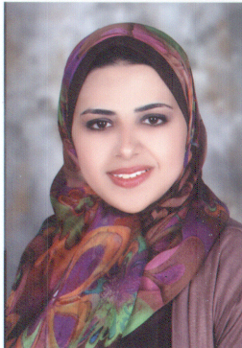

**Name : Nagwa Hamed Mohammed Salama**

**Data Of birth : October 24th, 1989, Egypt**

**Nationality : Egyptian**

**Address : No.7 El moahdaa st, Tanta, GHR, Egypt.**

**E- Mail : Eng_Nooga@Hotmail.com**

**Telephone : 0403293237**

**Mobile : 01211312912 / 01099066314**

**Marital Status : Married**

**Gender : Female**

**Objective**

**A challenging career opportunity that would give me the chance to be**

**an effective member of an executive team in a successful international organization with global opportunities**

**Education**

* **B.Sc. Civil Engineering, June 2011, Tanta University – Egypt**
* **Cumulative GPA :** **pass 63,18%**
* **Graduation Project : properties and strength of material**
* **Grad 0project Grade: Excellent**

**Training**

* **Training during study at department of el ESKAN (2009).**
* **Training during study at different locations in tanta such as Mr.Mohamed Elsawaf`s location with dr.moustafa elsawaf**

**(2010 & 2011).**

**Courses**

* **Course of ICDL, with grade Excellent.**
* **Course of AutoCAD, with grade Excellent.**
* **Course of sap (2000,vr 14), with grade Excellent.**

**Curriculum Vitae Nagwa Hamed**

* **Diploma in Information Technology Institute (ITI) in Graphic Design program :-**

**1- soft skills courses ( communication skills – presentation skills – time and stress management – team Building – E.marketing – Entrepreneurship).**

**2- IT courses ( introduction to internet – HTML – Adobe photo shop cs5 – Flash animation cs5 – Flash ActionScript- DreamWeaver – Adobe Illustrator cs5 – Adobe InDesign cs5 ).**

**Languages**

* **Arabic : Native Language.**
* **English : Very Good (Spoken, Written & Listening).**

**Computer Skills**

* **Excellent engineering drawing by AutoCAD.**
* **Very Good at Microsoft Office (Word, Excel and Power Point).**
* **A Very Good user & Searcher Of Internet.**

**Extra – Curricular activities**

* **Reading.**
* **Internet browsing.**

**Interpersonal Skills**

* **Self- motivated, reliable, creative, hard worker.**
* **Quick learner and aiming to learn more concepts by going into details of any required task.**
* **Able to work well both independently and in team environment.**
* **Good knowledge about International Codes and Standards**
* **Have a good spirit and cooperative with colleagues and supervisors.**