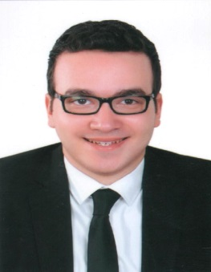**Mohamed Medhat Mohamed Mehrez**

01224935549

[mmedhat154@yahoo.com](mailto:mmedhat154@yahoo.com)

**Objective**

A challenging career opportunity in the field of banking that would give me the chance to be an effective member of creative team in a successful progressive organization.

**Education & Personal Data**

* Bsc .Commerce, English section (Accounting) – Tanta University 2015
* Graduation grade : Very good with honors
* Date of birth : 15/10/1993
* Nationality : Egyptian
* Marital status : Single.
* Military status : Exempted

**Work experience**

* Working in the PR and the marketing committee of Encatus Tanta from 10/2013 until now.

**Under Graduate Training**

**Aug 2014:**

Duration: - 1 month.

Bank: - Suez Canal.

**Dec 2014:-**

Duration: - 2 days.

Company: - Audit simulation in PWC Egypt.

**July 2014:-**

Duration: - 2 days.

Organization:- Enactus Egypt national competition.

**Courses and Certifications**

* Certificate in using Excel Accounting at Axon on July, 2015.
* Certificate in English "Conversation" at Axon on November, 2014.
* Certificate in Essential of Marketing and Personal Selling course at Arab Academy on Oct, 2015.

**Computer skills**

Excellent at Microsoft office Package

**Language skills**

Arabic: mother tongue.

English: very good.

**References**

Available upon request.