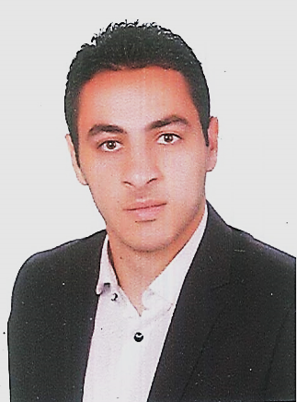

Elshrouk city,Helwan,Egypt

*Elgoharia,Mhalt-Marhom&*

Tanta, Elghrbia – Egypt

+201284074083 // +201145509257

| [https://www.facebook.com/galal.wereda.5](https://www.facebook.com/M.M.Elhady1)

[Galalwereda@Gmail.com](mailto:Galalwereda@Gmail.com)

GALAL BORHAM EBRAHEM WEREDA

|  |  |  |  |  |
| --- | --- | --- | --- | --- |
| * **Nationality** | **: Egyptian.** | * **Birth date** | | **: 2nd Feb 1991**. |
| * **Marital status** | **: Single.** | * **Military Service Status** | | **: completed.** |
| * **Gender** | **: Male.** |  |

***Objective:***

* To earn an experience in a multinational company and increase my experience in my field.

***Education:***

* **Metric from : Tnata AlAzhar Secondary School [ 2008 ]**

* **Graduated :B.Sc. in Electrical power and machines department ENGINEERING – ELSHROUK ACADEMY. – MAY 2014**
* **Accumulated Grade:** V. G with the degree of honor.
* **Senior grad :** Excellent.
* **Project grad :** Excellent.

***WORK HISTORY:***

* **Grad project** : PCB DRILLER using micro controller**.**
* **Other project :** power supply [ 2012, 2013 ] &

Star-Delta Starter && ATS Boards, DEC 2015.

***Courses:***

* Microcontroller.
* Classics control.
* Distribution.
* AutoCAD
* Mat lap.
* E-tap.

***Training:***

* Cairo oil refining.
* Cairo petroleum Gas Co.
* KORIMAT POWER STATION.
* EL MASRYA ELECTRICAL ENG &PROCUREMENT,DEC2015.

***Languages Skills:***

* **Native Language :** Arabic**.**
* **English** **:** Excellent.

***Computer Skills:***

* Windows and Microsoft Office (Excel – Power Point – Word).

***Technical Skills:***

* Team leader.
* Self-study.
* Word in a group**.**