Esam Mohamed Mohamed Omar



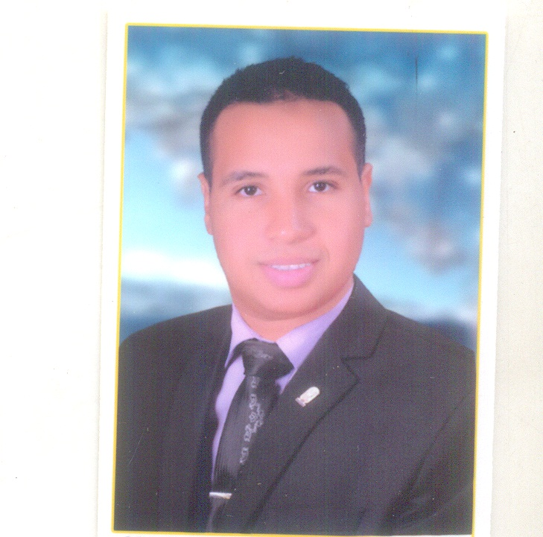
- ADDRESS : Naser City _ Sohag
- NATIONALITY : Egyptian
- BIRTH PLACE : Naser City _ Sohag
- Address in Cairo : New Elmarg
- DATE OF BIRTH : 4/5/1991
- SOCIALSTATE : Single
- MOBILE :01147703741
- Military status : passed
- E.MAIL : Esammm22@yahoo.com

- Awarded the bachelor’s degree in engineering sohag university
- Department : Civil engineering
- Division :Construction Engineering
- In: July 2014 With (C+ ) GPA :”2.38” of “4”( 71% )
- Graduation Project : “ Foundation Design “GP “1.7” of “4

LANGUAGES:
- Arabic : mother Tongue
- English : Very Good
COMPUTER SKILLS:
- AutoCAD 2007 , 2010
- Sap Course
- Rivit architecture
- Primavera
- International Computer Driving License ( ICDL )
- Ability to learn programs in short time

- Excellent ability to organize and manage a team.
- Problem solving & Decision making.
- Excellent communication skills with open mind for new ideas.
- Able to work under pressure and in multi track and ready to work in extreme condition.
- Ambitious.
- Like working in a team work.
- Hard worker, dealing with people.

- I work in the simple modern office for Engineering Consultants
- Training In Elmokawolon El Arab In Sohag for Construction Field
- Training In Housing and Construction In sohag
- Training In CEMEX
- Training In Faculty Of Engineering ,sohag University
- (Workshops and Laboratories Training :Soil ,materials and surveying )

Thanks for giving me this precious times of yours.

