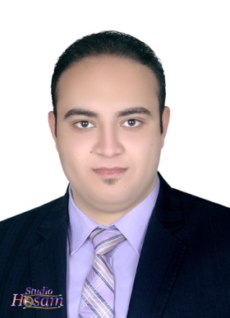

**Curriculum vitae**

***\** Personal Data \***

**Name : Abd Allah Moustafa Hussain Abo Hany**

**Address :**   **El dalgamoun - Kafr El-Zayat – Gharbia**

**Date of Birth : 19/9/1990**

**Marital Status** : **Single**

**Military Service**  **:** **Exempted**

**Email : Abdo.moustafa.abohany@gmail.com**

**Mobile : 01274480125 - 01096040701**

***\** Education*\****

**Bachelor of Sharia and Law.**

**Graduation year:2015**

**University : *Alazhar***

**Degree : *Pass***

**I am currently studying Graduate Diploma in ( Public Law )**

***\** Language *\****

**Arabic** **: Mother tongue .**

**English : Good .**

**\*Courses*\****

* **ICDL .**
* **Human Development**
* **leadership strategic thinking .**

**\*Experience*\****

* **Marketer Club sessions judges .**
* **Trainee Law Office .**