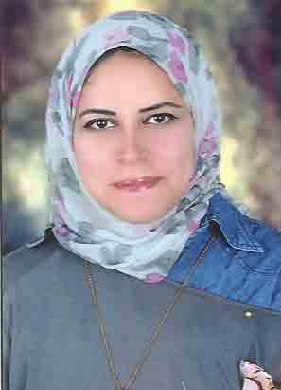 **C V**

**Name: Walaa Adly Mohiy Abd Eldaim**

# Phone: 01222627435

**Address:** **El gala ,st El shaheed hasneen bakr ,st**

## Personal Data

**Marital Status : Single**

**Data of birth : 4/2/1989**

**Religion : Muslim**

**Gender : female**

## Education

* **Bachelor of Commerce - Tanta University.**
* **Graduation Date : 2011**

## Computer Skills

* **Comfortable working on different versions of windows.**
* **ICDL from Biritsh International Institute.**

**Languages**

* **Arabic**
* **English**

**Courses**

* **English Course from Biritsh International Institute**
* **Soft Skills Course from New Horizons**

**Experiences**

* **Training as an accountant in commerce office.**
* **Work at Egypt Insurance.**

**Personal Qualities**

* **Hard working.**
* **Ability to work in team.**
* **Ability of Leadership achieving goals before deadline.**
* **Can work under stress and in a competitive environment.**
* **Ability to learn – Honest - Punctual.**

**References furnished upon request**