Kafer-elzayat  Tanta , Cairo Egypt | 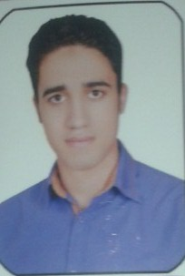  01009734367  01142978239  Moa12123@yahoo.com  moa.mmoo@gmail.com
Mohamed Omran Abdelrasoul
Personal Details | - Date of Birth : 1 / 12 / 1990  - Place of Birth : kafer-elzayat ,tanta, Cairo, Egypt  - Gender : Male  - Nationality : Egyptian  - Military Service: Completed
Experience | - 2 years in the company Sipes Paints
Education | - Al-azher University Bachelor of Commerce 2010-2014
Personal Skills  Language Skills | Active, Energetic, Ability to Work with a Team, Attention to Details, Ability to Handle Pressure & Initiative.  - Arabic: Mother Tongue  - English: Very Good
Computer Skills  Courses | - Operating Systems :  - windows 98 , Windows Xp , Windows Vista & Windows 7  (Installing , Configuring & Maintain)  MS-Office :  - Word , Excel, Power Point & Access  Has successfully completed course in  - human resources development  - accounting by using - peach tree  - Quick books\ commercial excel  - Soft skills  - Marketing and sales  - Accounting by using book keeping
Interests | - Reading, footBall, Computers.
Tips | - I believe that All or None.

Other information and documentation are available upon request.

