AHMED REDA MOSTAFA ISMAIL

SANADEED – TANTA – GHARBIA – EGYPT
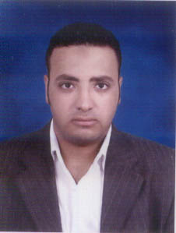
Marital status: single
Date of birth: 11/1/1986
Nationality: Egyptian
Military service: completed
Tel : +2 040 3041305
Mobile: +2 0111 63 012 63
: +2 010 98 094 095
Email: Army200520@yahoo.com

EDUCATION

· Bachelor of Commerce, Accounting Division

· Tanta University.

· Graduation Mark: Accepted (54%).

· Graduation date: July 2008.

.

TRAINING COURSES

· Has A Role (ICDL) Status Of Live Technology.

·Diploma Of The International Center For Computer
Languages (ILCC ).

COMPUTER SKILLS
AND COURSES

· Good knowledge of Internet and Windows XP.

· Good knowledge of Microsoft office package.

EXPERIENCE

. Year's Of Experience To Work In The Company (Goga Tex Textile Industries) From 1/7/2009 To 01/06/2010.

.Year's experience to work in the hotel (the Sheraton Sharm el Sheikh) from 1/7/2010 to 1/7/2011.

.Accountant at National Company for Trading and distribution of
connections (NTD) from 1/9/2011 till date.

LANGUAGE SKILLS

INTERPERSONAL

REFERENCES

· Arabic (Mother tongue).

· English (Good).

S

. Highly Committed, Enthusiastic And Eager To Learn About Work.

. Team Work And Cooperation Skill.

. Ability To Work Under Pressure And Deadlines.
· Ability Lo Learn New Skills.

· Available Upon Request.

