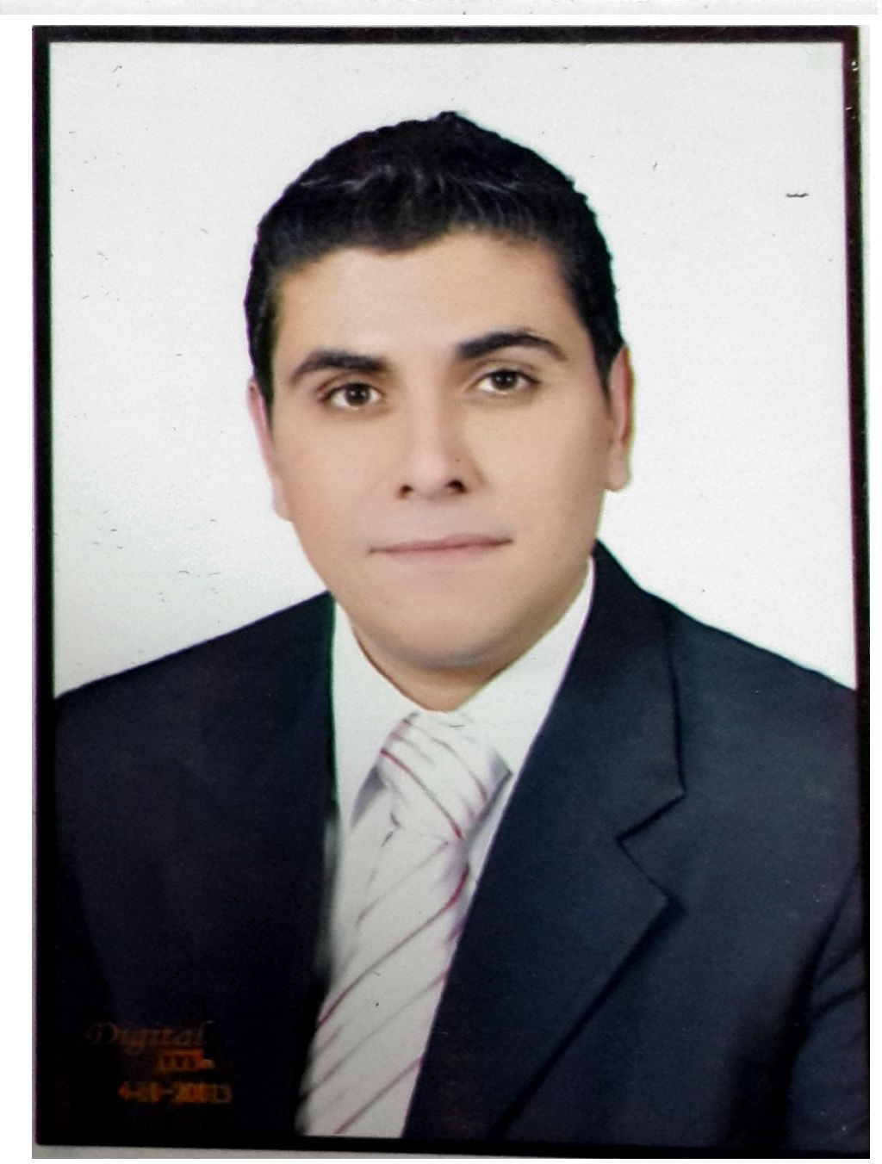

**Personal Data**:

* **Name: Mahmoud Mohamed Mostafa ALzoghpy.**
* **Birth date: 25/10/1987**. .
* **Gender: Male.**
* **Nationality: Egyptian.**
* **Marital Status: married.**
* **Military Status: Exempted.**
* **Telephone: (+2040) 3071427.**
* **Mobile:(01288839073).**
* **Driving Licence:** **privet.**
* **E-mail:**[**Mahmoud_ALzoghpy74@yahoo.com**](mailto:Mahmoud_ALzoghpy74@yahoo.com)**.**

**Education**:

**B.Sc. Degree : B.Sc. of Commerce, Accounting Dept.2012**

**Faculty of commerce, Tanta University, EGYPT, with grade accepted.**

**Languages:**

**. Arabic : Native.**

**. English: Very Good speaking and excellent writing.**

**Courses &Computer Skills**:

* **Word, Excel, PowerPoint, FrontPage, Access, Internet Applications and Tools.**
* **Good knowledge to windows 98, XP, 2000.**
* **Microsoft Internet Explorer.**
* **Good practical on accountant programs (Al FIAD).**
* **Practical training in Dr/Shawky el Hefnawy office. (Accounting office)**

**Skills:**

* **Very Good Educational Skills.**
* **High creative and strong communication and presentation skills.**
* **Have a good spirit and cooperative with colleagues and supervisors.**
* **Able to work under pressure in various locations and irregular**

**Working hours and days.**

* **Intelligent, highly qualified and hard working person.**
* **Able to deal and contact with different customer**
* **Have experience in preparing Financial Statements and daily Entries.**

**Career Objective**:

* **My objective is to work in a place where I can utilize what I have learnt during both my years of study and my later experience, in order to play a role not only to maintain, but also to improve the performance of the place in which I’m working**.

**Practical experience**:

1. **Training at Dr/Shawky el Hefnawy office. (Accounting office)**
2. **Worked as Auditor in "EL_MASHD AND EL_GHRAPLY CO."**
3. **Worked as Stores Accountant in "Egyptian Company for Melamine Paper" from 26/3/2009 till 24/12/2012.**
4. **Working as financial Accountant in "Egyptian Company for Melamine Paper" from 25-12-2012 till now.**