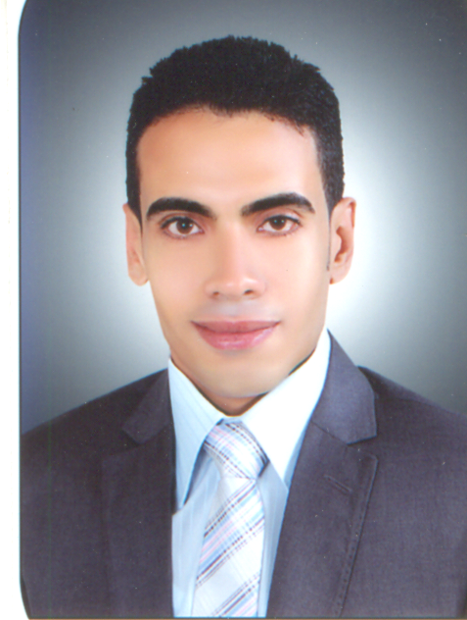
Ahmed Elhosseiny Ahmed Morsy

Address: 14 Mohammed Geaisa st. from Naif Emad st. , Tanta, El-gharbya, Egypt
Mob: 01007241739 / 01282110221
Tele: 040-3298319

E-mail: ahmed_elhosseiny123@yahoo.com

Educational background:

Education:

May 2011 Bachelor degree in Commerce, Tanta University.
Major: Accounting.
Cumulative Grade: 3321 of 5300 (62.6%).

Extra courses:

Oct. 2012 General American English course (levels 1 – 12).

July 2012 communication skills

MAY 2012 Sales & negotiation skills (how to attract and persuade
Customers to deal with my organization).

Jan. 2012 Customer service skills .

Sep. 2011 Business _ MS project .

Nov. 2011 Peachtree Complete Accounting course.

June 2010 International computer driving license (ICDL) course.

Work Experience:

1, Oct. 2015_ Until now Working for chemipharm for Pharmaceutical Industries
As a Sales Representative .

1, Jan. 2014_ 30, sep. 2015 Working for Start Academy as a Marketing Manager

1, Sep. 2012 – 31, Dec 2013 Working for International British Institute (IBI) as a
Marketing Representative.

1, Oct. 2011 – 31, May 2012 Working for the International Investment and Trade
Development Company as an accountant.

Personal Skills:
- Creative, self motivated, reliable & dynamic.
- Enthusiastic, energetic, positive thinker.
- Ability to work individually and as a co-operative
team member.
- Have an excellent interpersonal skills communication skill, presentation skills and the ability to work under Pressure .

Interests:
- Reading and surfing the Internet.
- Travelling and playing Football.
Languages:

  - English language: V. good in writing, reading and speaking.

Personal Information:

Date of birth: 3rd July 1990
Marital status: Single.
Nationality: Egyptian.
Military service: Exempted.

< References are available upon request >

