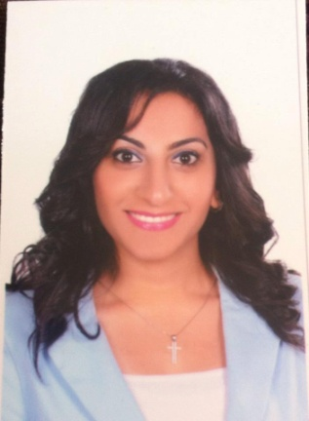
Youstina Raafat Helmy Gerges
Address: 42 ElTokhy ST . From Ali Moubarak ST , Tanta, El-gharbya, Egypt
Mob: 01200026925
Tele: 040-3331449

E-mail: Youstina_Raafat1234@yahoo.com

Educational background:

Education:

May 2015 Licentiate Faculty of Arts Tanta University
Major: Geography Department – Survey .
Cumulative Grade: Good
Estimate the graduation project : Good

Extra courses:
Sep 2015 Surveying devices (Level_ Total station_ Theodolite & GPS )
Sep 2015 Surveying Software (Auto cad 2D _ Surfer_ Prolink)
June 2015 International computer driving license (ICDL) course.
Oct. 2014 General American English course (levels 7 – 10).
June 2014 Training in land situation Mahalla – Arab Contractors
Personal Skills:
- Creative, self motivated, reliable & dynamic.
- Enthusiastic, energetic, positive thinker.
- Ability to work individually and as a co-operative
team member.
- Have an excellent interpersonal skills communication skill, presentation skills and the ability to work under Pressure .

Interests:
- Reading and surfing the Internet.
Languages:
  - Arabic Language: Mother Language .
  - English language: good in writing, reading and speaking.

Personal Information:

Date of birth: 27 / 5 / 1993
Marital status: Single.
Nationality: Egyptian.

< References are available upon request >

