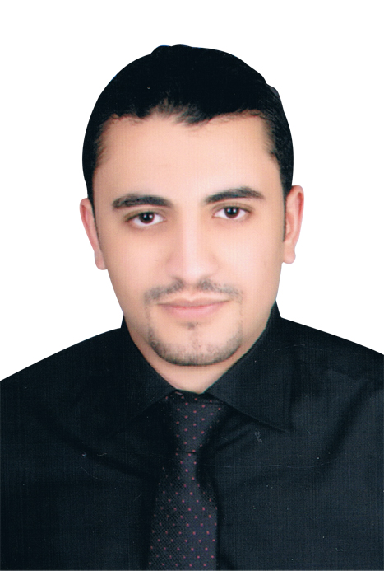
Hossam Saied Mohamed Khattab
9 Ibrahim Abd El-Gawad Street – El Galaa, Tanta
Mobile: 0128 40 85 241
Telephone: 040 329 45 85

pERSONAL INFORMATION
- Date of birth: 1/8/1992
- Email: hossamkhattab92@yahoo.com
- Nationality: Egyptian
- Marital Status : Single
- Military Status : Completed
profile
- Communication skills.
- Leadership Skills.
- Planning and organizing.
- Observation and problem solving skills.
- Time management and coordination skills.
- Self-confident
- Motivated
- Flexible
- Teamwork

experience
CGAA (Consultative Group For Accounting & Auditing) : [December 2013 – Till May 2014] Responsible for Public Relations , Marketing , monthly payroll administration ,Tracking time attendance for employees and record absence and lateness cases and some personnel related tasks.

Training
Training in Accounting (1 year) (Consultative Group For Accounting & Auditing)
.
Education
B.Sc. of commerce, English Section Accounting Dep., Tanta University 2014se
Courses
1-year Experience in Accounting CGAA 2014
(Consultative Group For Accounting & Auditing)
Comprehensive Accountant Diploma CGAA 2014
Taxes Course CGAA 2014
Contracting Course CGAA 2014
Accounting Excel CGAA 2014
ICDL (Version 5 ) / MS Office CGAA 2014
Mini CMA Hi-Q 2012
Conversation English (Level 12) IWI (International Washington Institute) 2013
Human Resources (HR) British Center For Languages & Computer 2014
Languages and computer skills
- Arabic: Mother tongue.
- English: Good Command written & spoken.
- Practicing MS Office applications.

JOB Code
(Job Code: ACC101)

