CURRICULUM VITAE
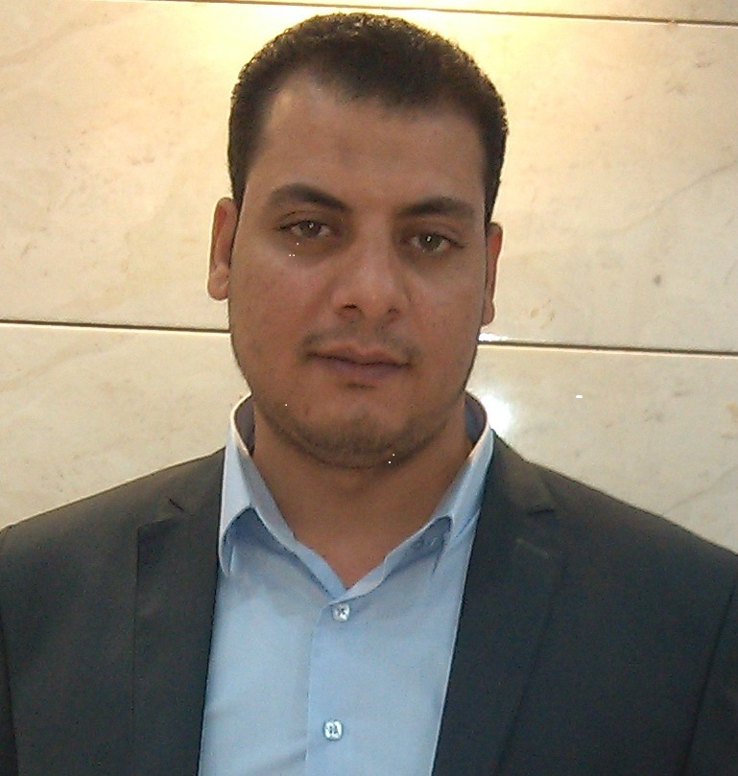

Name Hamdy Ali Abd Elatief El sheikh
Address Egypt; Gharbiya. Elsanta – Elsanta Elbalad
Telephone +201007346919
Mobile +201012291769
E-mail hamdy.elshiekh2010@yahoo.com
Date of birth 3/1/1981
Nationality Egyptian
Sex Male
Marital status Married
Military Status: Led military service

Education/Qualifications

2002 Bachelor's degree in Commerce, Tanta University.
Specialization / Division of Accounting.
Graduation Year / role May 2002

Employment to Date/Work Experience

1/2005 – 6/2005 Store keepers - Ghazala Grand hotel (Sharm Elshiekh)

6/2005 - 11/2007 Cost Accountant - Coral Sea resort (Sharm Elshiekh)

6/2007 - 8/2009 Inventory - coral beech Tiran resort (Sharm Elshiekh)

8/2009 – 7/2014 Sales accountant and clients - Elsanta Company for Poultry
- Processing (Elsanta – Gharbiya)

7/2014 – To Date Treasury references - Al Mazloum for trade and agencies (Tanta)

Languages •
Arabic: Mother tongue.
English: Good.

Other Skills
Computer literate: Windows applications.
Proficiency in data entry work
Proficiency in working on Microsoft Office
Outlook
Word
Excel
PowerPoint
Access

PERSONAL STATEMENT

I’m an experienced Accountant looking for a new opportunity within a large or small operation in your company.

Personal characteristics and activities

- Love to work in a team.
- Hard work.
- Very willing to learn new tasks and the ability to absorb them.
- Ability to work under pressure and the ability to carry additional
Burdens.
- Finally, I have the honor and adore the work I am an accountant

References.

References are available on request

