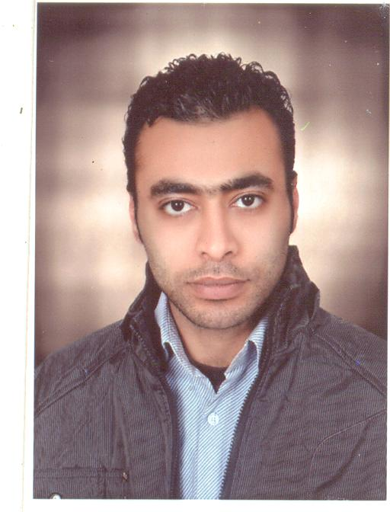
  ِِAhmed Nasr Abd El hamed Sherif
  Contact Information »
  Address: | Tanta - Gharbya
  Mobile Phone: | 01229623839  01091634262
  E-Mail: Ahmednasr_sherif@yahoo.com

Personal Information

 | Nationality: | Egyptian
 | Birth date: | August 30, 1983
 | Gender: | Male
 | Marital Status: | Single
Languages

- Arabic | Native Language
- English | good

 | - Faculty of Commerce Zagazig University – Zagazig - Egypt (2005) Grade pass
Computer Skills

Well command of software applications such as:
- Certified of ICDL Microsoft Office XP Applications.
- Microsoft Office Applications (2000, XP and 2003)
- Windows (2000, XP and 2003)
Work Experience

- I work as an accountant at the sunny days hotel in Hurghada.(from march,2015 till now)
- I worked as a receiving clerk at the pyramisa , sahl hasheesh .(from October, 2014 till february,2015)
- I worked as cost control in the red sea fish restaurant in sharm. (from January,2014 till August,2014)
- I worked at the Ali Baba hotel in Hurghada as (cashier, head cashier, night auditor for food & beverage and tele, receiving and finally as an accountant in medical centre). (September,2007 till November,2011)
- I worked as a data entry in the store medications.

Other Assets

PERSONAL SKILLS:

· Enthusiastic ambitious worker.
· Good interpersonal skills and commitment to service.
· Attention to details.
· Ability to work under pressure.
· Self-motivated to take initiative and responsibility.
· Desire to win and succeed in any scenario
· Plan, prepare and coordinate events and educational programs.
· Experience in solving issues through flexibility and innovation.
· Posses the ability to liaise with individuals at all levels of organ

INTERESTS:

Health, internet.

Thank You for taking the trouble of reading this document.

References available upon request

