c.v

Objective

To enhance my experience and increase opportunities to achieve a good position and a good work reputation at your work team.

Personal Information:
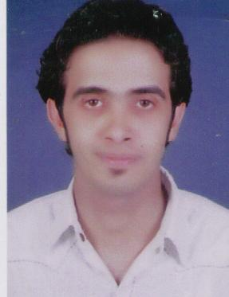

Name: Amr Badawy Zaki
Gender: Male
Date of Birth: 16/03/1983
Nationality: Egyptian
Marital Status: Single
Military Service : Deferred
Address: Egypt- Giza –Embaba- 13 Mohmmed Amer .st
Telephone: Home( 01010290529) , Mobile ( 0123108378 )
E- mail : amrbadawy42@yahoo.com

Scientific History:

University : Higher Institute of advanced studies in the Al Haram

Specialist : Information systems Adre
Year of Graduation: 2005
Degree: PASS
Graduation project degree : "excellent."
Graduation Project: " Web Site "…

Languages Proficiency:
Arabic: Mother Tongue

Special skills:

- I think I can deal well with customers because of the nature of my work, I also have the ability to persuade, and the creation of the working group, coordination and management, including the preparation of reports, analysis and statistics, and respect for work and follow-up visits
- Excellent communication and presentation skills to facilitate contacts through the transfer of objectives clearly and effectively
Professional strengths

- cooperative relations with a broad base of experience in working with people.
- the ability to assess the situation and successful implementation of action plans
Computer skills:

- Excellent in dealing with computer
" photoshop – webstyle –swish – frontpage- office2003-2006 – internet"
Work experience:

- Work In first services company (2 yaer )orascom telecom ( customer servies manager )
- Work In El ABD inter Trad Company ( customer servies manager )
- Work In American Life Insurance Company "ALICO" Agent
Achievements:
مساعد رئيس قسم ارضاء العملاء بشركة العبد للاجهزه المنزليه ( وايت بوينت ) من 5 سنوات ومشرف حركة بالفرع الرئيسى بالمهندسين
مشرف خدمة عملاء بشركة اكوا توب
مراقب مخازن ( مراقب التقارير الخاصه بحركة اضافة وصرف المستلزمات الطبيه للمخزن )بمستشفى ابن سينا بالدقى
AAWمدير ادارى بشركة المهندسون الاستشاريون
الحصول على شهادة التميز فى خدمة العملاء من مركز اعداد القاده بالعجوزه
الحصول على شهادة التميز فى خدمة العملاء من اكاديمية ايماك بالمهندسين
الحصول على دورة ( المدير المالى ) من الاكاديميه المصريه لتدريب المحاسبين بالعباسيه
الحصول على دورة SQ L SERVER من وزارة التضامن الاجتماعى
الحصول على شهادة ICDL
It is a fact that I am truly a member of your team
Thank you for giving me this precious time
AMR BADAWY

