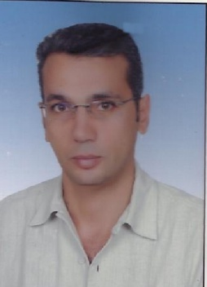8 Abo Bakr El Sedik St.

Tanta, Egypt

12 Nakhlah El Moteiae

Cairo Egypt

01002936175

# [mohamedobya@yahoo.com](mailto:mohamedelbahy71@gmail.com)

Mohamed Shalaby obya

|  |  |  |
| --- | --- | --- |
| Objective |  | Providing outstanding customer service and cost control. Detail-oriented, Processes a high volume of purchase orders with a commitment to accuracy. Positive, Creative, focused on bottom-line results and dealing with multi-tasks. |
| Skills & Abilities Work at….. |  | * Good industrial knowledge * Very good in computers * Excellent negotiation skills * Strong networking skills * An expert in market-research   ***Ceif Account at Semco Construction…El Ainelsokhna***  from 9/2014up tell now |
| Professional Background |  | Managing Director in Ramadan hospital From8/2011 to9/2014 Purchasing Manager, Grand Hotel – Sharm El Sheikh Aug 2010- May 2011   * Corporate of Purchasing with negotiations for goods and services. * Assisting in establishing Purchasing Policies and ensuring compliance. * Trace the arrivals from Purchase Orders. * Work with Quality Control department to ensure timely release of ingredients.  AssistantPurchasing Manager, Siva Grand Beach-Hurghada Jan 2010-Aug 2010   * Direct and supervised the activities of purchasing/expediting team (successfully mentored associate team member). * Control annual departmental purchasing budget and inventory holding. * Introducing value adding changes within department. * Negotiating drafted and implemented major Supply Agreements. * Monthly management reporting.  Purchasing Supervisor, Grand Hotel, Hurghada Dec 2008-Dec 2009   * Compute all purchase orders for multiple manufacturing facilities. * Prepare and submit quotes to customers and provided them with status of orders as needed. * Prepare and issue purchase orders using automated accounting package. * Negotiate pricing and credit terms with existing and new vendors.  Purchasing Clerk ,Grand Hotel, Hurghada Sept 2006 -Dec 2008   * Maintaining records of materials, prices, inventories and deliveries, * Using these records to compare prices, specifications and delivery dates so that my * hotel can save money by choosing the supplier that provides the greatest value.   **12 years' experience aria sales manager in different company** |
| Education |  | Technical Commercial Institute , Finance department, 1994 |
| CORE Strengths |  | |  |  | | --- | --- | | * Customer Service | * Policies & Procedures | | * Vendor Management | * Cost Reduction | |  |  | |  |  | |
| I.T Knowledge |  | Expertise in using Microsoft Tools namely Word, Excel, WordPerfect. |
| Technical Skills |  | * Training Skills * Communication Skills * Customer Service * Administration- Leadership |
| Languages |  | * Arabic – Mother Tongue. * English – Very good |
| References |  | REFERENCES FURNISHED UPON REQUEST |