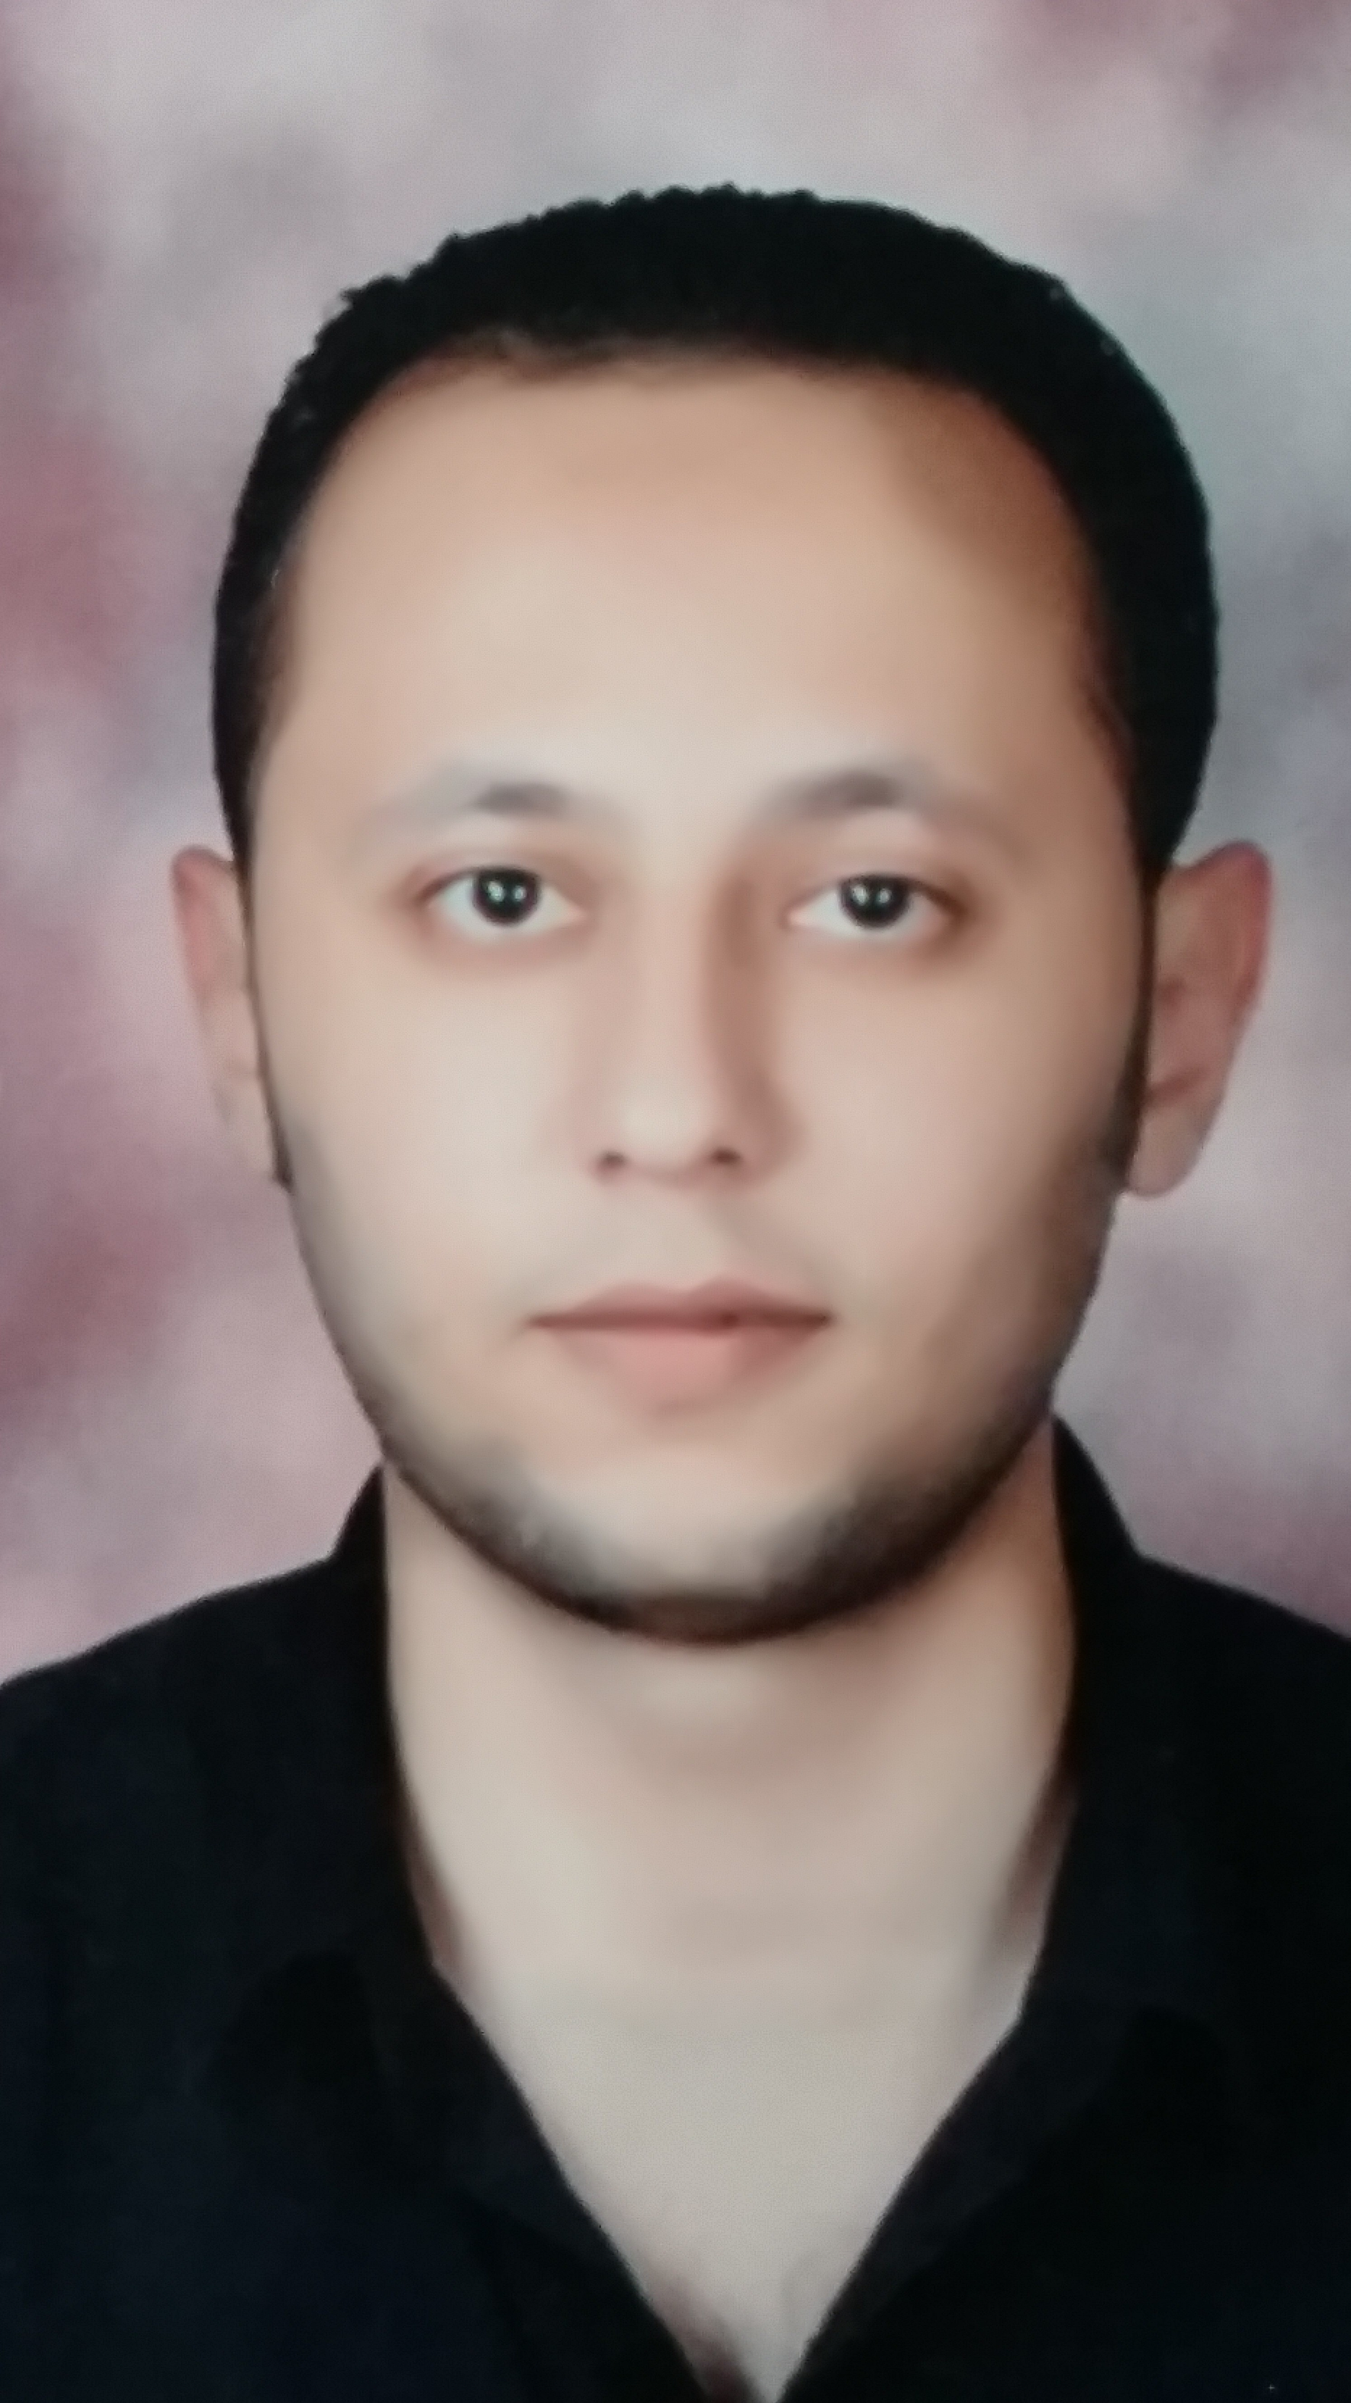
mohamed ibrahim salama
Address: - Egypt
Cell Phone: - +201119922580
E-Mail:- mohamedsalama852@gmail.com

PERSONAL PROFILE
Ambitious and energetic composed under pressure and get along very well with people at all levels. Possess excellent correspondence & communication skills. Very Organized with professional approach.
Age & Date of Birth : 14, July 1987
Marital Status : Married
Military Status : Exempted
Nationality : Egyptian
Driver license : Valid
ACEDEMIC & PROFESSIONAL QUALIFICATIONS
Bachelor of Commerce : Accounting Division. (2008)
Computer Knowledge : Microsoft Office – Excellent (ICDL certificate).
Hardware and Software : Wide Knowledge in Installing Configuring and
Maintaining Computer.
Other : I currently studying Certified Management
Accountant (CMA) Part two in the American
University in Cairo (AUC) Start in august 2015
: I studied General English in the American University
in Cairo (AUC)
: I studied PFAD (Professional Financial Accountant
Diploma).
- ACCOUNTING PRINCIPLES &CONCEPTS.
- INVENTORY STANDARD.

- FIXED ASSETS ATANDRD.
- PROVISIONS & ALLOWANCES.
- WAGES & SALARIES TAX.
- ACCOUNTING ERRORS AND CORRECTION.
- ACCOUNTS RECEIVABLE.
- PRESENTATION OF FINANCIAL STATEMENTS.
: I have Experience and Familiar with computer
Operating systems.
: I have Experience in accounting software
(QuickBooks and Peachtree).
SUMMARY OF EXPERIENCE
( From, Sep 2011, working as an Accountant in the Egyptian food industry. (Welatain).
( From, Mar 2010 worked as an Accountant in the International Group for the
Training of Accountants (IGTA)
( From, June 2009 worked as a Data Entry in company for the manufacture of glass.
( From, May 2006 worked in El-Masrya for computer installation and maintenance.
OBJECTIVE
I can utilize my knowledge, various skills & experience in contribution towards fulfilling the company’s growth objectives, develop my career and excel in the related field.
PERSONAL STRENGTHS
Friendly and easy going with people, keen observer, fast learner, able trainer & good listener.

