 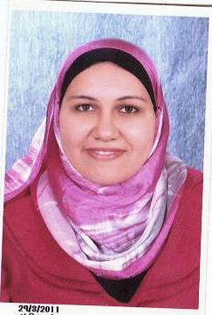

|  |
| --- |
| Personal Data |
| Name : Manar Adel Hassan  Date Of Birth : 01/05/1989  Nationality : Egyptian  Marital Status : Single  Address : 27 B Magles El- Shaab St.  Tel. : 01150033675  E-mail : [mr_mr15@hotmail.com](mailto:mr_mr15@hotmail.com) |
| Education |
| * Advanced Studies : Accounting and auditing Diploma .   From : Faculty of Commerce - Cairo University.  Date : 2015   * University : Helwan University.   Faculty : Faculty of Commerce.  Department : Accounting.  Graduation Date : 2012 |
| Knowledge, Skills and Ability |
| Language Skills:   * + Arabic: Mother Tongue   + English: V.Good   Computer Skills:   * Microsoft Dynamics ax. * ICDL (V.5). * MS OFFICE 2003, 2007, XP & Vista.   Personal Skills:   * Communication skills , Team work. , Working under pressure . * Improving my current job and keep up with the constantly changing work environment for the company and help in the development of this field of work. |
| Experience |
| * FROM 24/9/2013 UP TO Now:- * Company Name: MAR Company (Imp. & Exp. Company) * Title : Accountant * FROM 27/12/2012 UP TO 15/10/2013 :- * Company Name : Resala Charitable Organization * Title : Accountant * Training in 2007 , 2008 , 2009 :- * Company Name: Arab African Int’l Bank * Title : Training Many of Banks Jobs |
| Courses |
| * Microsoft Dynamics ax. * ICDL (v.5) * Financial Accounting in English * Principles Of Stock Market * English Course * Human Resources Course |