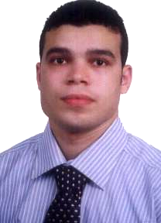
Curriculum vitae

Personal Information:
Name : Mohamed Al-Basyoni Mohamed Megahed.
Nationality : Egyptian.
Date of Birth : 8-8-1986
Place of birth : Tanta
Martial Status : Single
Address : 52 Abd El-MetaalSt, Al-Agezy ,Tanta, Egypt .
Telephone : (+2) 040 3520413
Mobile : (+2) 01013500101
Military service: Exempted .
Driving License : Have a private license .
Email : Mohamedkasm99@yahoo.com
Academic Information:
University : Tanta University
Faculty : Faculty of Commerce
Department : Accounting
Graduation Degree: B. Sc of Commerce specialization in Accounting.
Graduation Year : May 2008
Qualifications:
- Have international computer driving license (ICDL).
- Have a certificate in accounting course in financial accounting.
- Have a certificate in English language.
- Course in Excel Application.
Language:
- Well command of English writing and speaking
- Diploma in English Language and conversation ( 6 levels )
- Native Arabic speaker
Computer Skills:
- Professional Course in Microsoft Windows and its programs specially MS Word and MS Excel
- ICDL Course .
- Have a knowledge of other Accounting programs like ADVAC , Peachtree.
Last Experience:
- Work As Accountant in Accounting Office .
Job Description :
- The preparation of work sheets and Documentation
- Registration in the books
- Work Analysis of the budget preparation .
- Taxes .

2.work as accountant in Delta Misr company for commercial agencies.

3- work as accountant in Al Dakhil for Agricultural and trading Establishment in Qassim in kingdom of Saudi Arabia from April 2011 up to April 2015.

