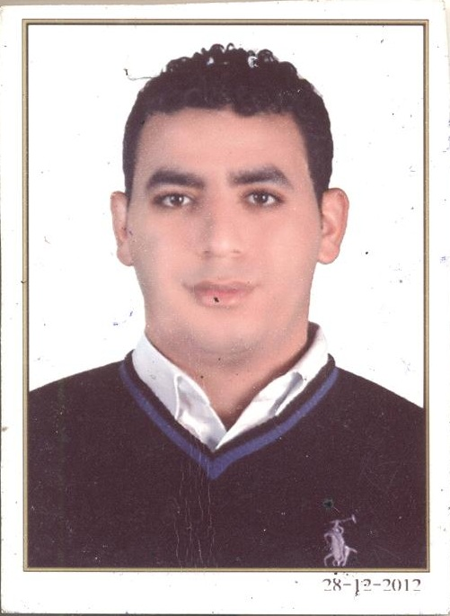
Personal Details
Name : Ibrahim Hamdy Ibrahim Mohammed Abdeldaym
Mobile No : (+2) 01069859961 Home Telephone: (+2) 040 5610673
Address : Mit el Haroon, zefta, El Gharpya, Egypt.
Email : ibrahim0hamdy0@gmail.com
Date of birth : 1 January 1990
Marital Status : Single
Military status : Postponed
Nationality : Egyptian
Objectives
I'm looking forward to conduct a successful professional career by contributing in the success of a unique company. Get into real life using all the academic experience & my personal skills.
Education
- Graduated from Tanta University Faculty of Commerce.
- Graduation Grade: pass.
Work experience.
- Working at DELTA For Construction & Rebuilding as Aditor from 01 Sep 2015 until now and as Acting Director of Accounts

- Working at DELTA For Construction & Rebuilding as Accountant from 01 Sep 2014 until now as Super Visor of Genral Accont
- Worked At Egyption Chinees Company For Import And Export For One Year as an Accountant
- Worked at Assonation Of Business And Invistors as an Specialist Credit For One Year
Language skills
- Arabic : Mother tongue.
- English : Very Good "writing& reading"
Courses
- General English skills; Ministry Of Defense Language Institute.
- Certified ICDL-UNISCO.
- Certified PDFA.
- Certified Path way.
Computer skills
- Good experience in Microsoft Office Package.
- Solid background in computer hardware.
- Capable of learning and handling any software packages.
- Capable of dealing with Windows operating system & Internet tools.
Personal Skills & activities
- Flexible and able to work under pressure.
- Excellent communication, interpersonal& negotiation skills.

