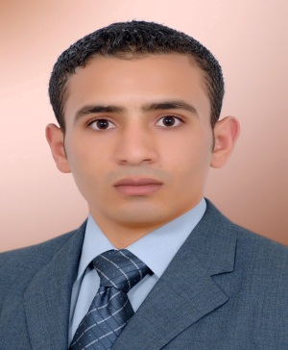

**Mohamed El sayed Abd elrashied Sultan**

Telephone : **+2-010-01563363 - +2-012-81922284**

E-mail : [M_sultan1050@yahoo.com](mailto:M_sultan1050@yahoo.com)

*---------------------------------------------------------------------------------------------------------------------------*

**Career Objective:**

Seeking a responsible job with an opportunity for professional challenges in the accountant field to enhance my skills, and increase my experiences.

**Personal Strengths:**

* A professional approach and attitude to the workplace.
* The ability to work within a team context, supporting and motivating colleagues.
* Able to work efficiently unsupervised and achieve targets independently.
* Able to work under pressure.
* Excellent communication skills both written and oral.
* Excellent time management and organizational skills.
* Confident decision maker.

**Computer Skills**

* Microsoft office (word – excel – power point )
* Windows
* Internet

**Language Skills:**

* Mother tongue Arabic.
* Fluent level of formal and conversational English.

**Job Experience:**

* working in 2. E. M company investment and transport

In position responsible treasury (accountant) from 2010 to 2011

* Work in the Kingdom of Saudi Arabia at Abdul Rahman Hamad Sunaidi Trading & Contracting Company In function accountant in Kasem from 2011 to 2013.
* work in quality foods for trade&industry sales accountant Branch banha .

**Summary of Qualifications:**

* BC of commerce – Accounting [May 2009]
* Faculty of Accountant- Menofia university
* Grad - Good

**Training & Courses:**

* ICDL
* Training in the Bank development and credit.
* Training on Financial statements. And Trail Balance.
* Experience and skill in dealing with progrms E R P
* Electronic Accounting
* Accounting Applications using Excel

**Personal Interests:**

* Reading
* Music
* Personal health and fitness

**Personal Data:**

* Date of Birth: February 16th 1988.
* Place of Birth: Quesna, Egypt.
* Nationality: Egyptian.
* Marital status: Single.
* Military status: Exempted.