Andrew Atef Gerges
Front office Team Leader

Personal Data
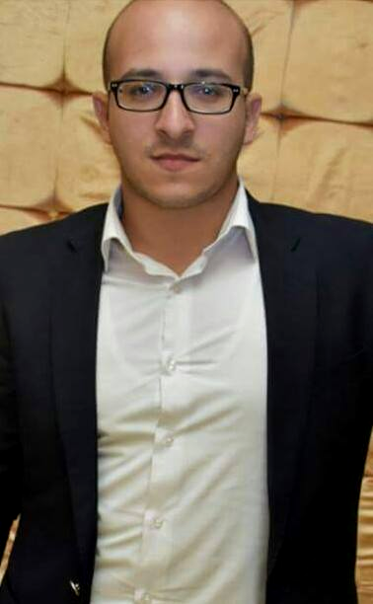

- Current Location : El Gharbia , Egypt
- Nationality : Egyptian
- Date of Birth : 28 November 1989
- Civil Status : Single
- Languages Spoken : Arabic, English , Russian
- Height / Weight : 170 CM/ 77 kg
- Telephone : 00201015237939
- Email : andrewatef752@gmail.com
- Skype : andrewreception

Education

Bachelor of Tourism and Hotels, Alexandria University, Hotel Management department May 2010.

Work Experience


Panorama Naama Heights Resort www.Panorma-resorts.com
4* hotel 250 rooms and suites, Egypt, sharm shikh city
Front office Team leader November2010 – September 2013
Reporting to: Front office Manager

- Supervise front desk associates to ensure that all hotel policies, procedures, regulations and standards are followed.
- Ensuring that front desk operations runs smoothly in a professional manner at all times.
- Perform all front desk related responsibilities and duties when assigned or required.
- Assume leadership in the absence of front desk manager
- Ensure appropriate and adequate training of all front desk associates including all on-the-job, off-the-job and 15min training.
- · Ensure daily all forms of communication are used to full capacity and relevant information is handed over to the next shift through out the shift and briefings.
- Ensure smooth check-in and check-out of all guests, and proper handling of all guest accounts.
- Ensure that all arrivals, departures, no shows, extensions, amendments and OPERA related matters are performed on a timely manner in order to avoid confusion.
- Be fully aware of Credit Policy and supervise compliance. Inform your manager and concerned departments about any possible credit risks.
- Run the night operations for the hotel; ensure proper closing of the day and delivery of the reports.
- Identify and resolve guest's problems efficiently and resolve to the guest satisfaction.
- Assuring that all front office receptionists are continually updated with hotel rates, packages and discounts.


Dessole cataract resort & Layalina www.dessolehotels.com
4 * Resort 224 rooms and suites, Egypt, sharm sheikh
Guest service Agent June 2014 – November 2014
Reporting to: Front office supervisor

- Registers and rooms all arrivals according to established procedures
- Maintains intimate knowledge of departmental standards and procedures
- Cashes hotel guest's personal and travellers checks and assists with currency exchange
- Responsible and attends to guest's request of using the service of safety box at all times
- Knowledgeable of all special promotion procedures, for programs. Attends to guest's complaints, inquiries and requests, referees problems to supervisor / Assistant Manager if He / she unable to assist
- When on night shift, prepare all necessary forms for the guest arrival
- Maintains comprehensive knowledge of standard reservation procedures including correct forms to use, how to read e-mail, messages, and how to interpret availability sources within the reservation systems
- Takes personal interest and pride to ensure that the front desk work area is kept clean and in an orderly state all times.
- Monitor all key accounts.
- Monitor and follow up the Police report.
- Check the reports for Head Housekeeper and notify him/her of any discrepancies.
- Establish the daily accommodation report and register any cash transactions.
- Responsible for the cashiering procedures in the department.
- Register check in and departures of all individuals and groups.
- Check the remaining departures and make sure that the corresponding bills are ready and correct with the supporting documentary proof.

Sonesta club resort www.sonesta.com
4* star hotel 418 rooms and suites, Egypt, sharm sheikh
Front office Team leader November 2014 – March 2016
Reporting to: Front office Manager

- Prioritize and delegate daily work responsibilities to front desk staff.
- Train and guide front line staff to provide quality customer services.
- Manage staffing schedules, shift changes, payrolls, and labor costs.
- Resolve guest issues and enquiries to ensure guest satisfaction.
- Plan shift schedule and duties based on business forecast.
- Supervise the billing and cash processes to ensure compliance with company standards.
- Provide feedback to the team members on their performances and improvements.
- Advise housekeeping staff when rooms have been vacated and are ready for cleaning.
- Responsible for assisting guests with check-in and check-out, plus all special requests for services or information, in accordance with SOP's.
- Ensures all members of the staff are completely familiar with all hotel emergency procedures.
- Works with desk agents to balance at end of shift and ensures completion of shift checklist.
- Smiles and greets all guests immediately in a gracious and professional manner; handles all guest questions and problems within empowerment guidelines.

Language Skills

Arabic : Mother Language

English : very good both written & spoken

Italian : fair written & spoken

Russian : very Good Spoken and understand

Training

The International Computer Driving License (ICDL)

International English language testing system (Ielts) with overall 5.5 Academic and general.

Achievements

- Awarded as Employee of the Month for Oct 2015 (sonesta hotel sharm sheikh)

Computer skills
- Internet. (Very good)
- Word. (Very good)
- Access. (Good)
- outlook (very good)
- opera soft ware for F.O (very good)
- suite 8 soft ware for F.O (very good)
- Photoshop. (Very good)
- Excel. (Good)
- PowerPoint (Very good)
- Comsys soft ware for F.O (very good)

Personal Skills

- Enjoy dealing with people and solve problems
- Be patient and tactful
- Have good written and spoken communication skills, including a pleasant telephone manner
- Calm under pressure
- Able to think quickly and solve problems
- Able to multi-task
- Have keyboard and computer skills
- Professional appearance
- Good knowledge of the company and its staff
- Excellent interpersonal skills
- Good organizational skills
- Tact and discretion

Interests

- Music, Playing Outdoor Games, Reading, playing sports and gym training.

References

Name: Mr. Amr Fathy
Position: General Manager
Company: panorama name heights sharm shikh
Telephone No: 00201110122021

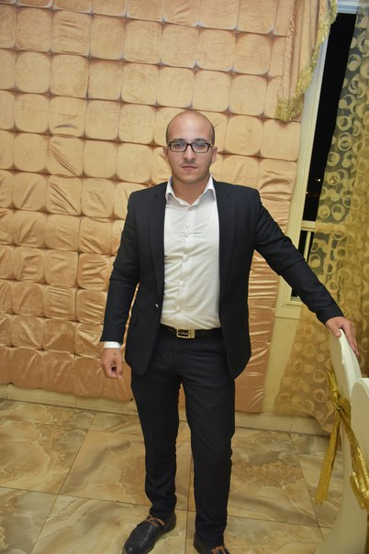
Name: Mr. Sami Mikhail
Position: Front office manager
Company: Dessole city sharm
Telephone No: 00201221833872

Name: Mr.abdelhamid
Position: Front office manager
Company: sonesta clup sharm shikh
Telephone No: 00201227463818

Name: Mr.Ibrahim Hezima
Position: Ass .Front office manager
Company: sonesta clup sharm shikh
Telephone No: 00201142743720

