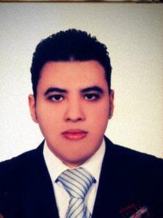
Personal Information:
Name: Mohammed Abd-Elmawla Mohammed Kamel Elwerdiany
Mobile | : +21115161872
E-mail | : elwerdiany@yahoo.com
Address | : Beheira
Date Of Birth | : 1th-oct 1987
Nationality | : Egyptian
Religion | : Muslim
Marital Status | : Single
Military Service | : Exempt from military service
Educations and qualifications:
( Bachelor’s degree of commerce Department of Accounting)
University | : Alex University Damanhur branch
Graduation Year | : 2008
Language Skills:
Arabic | : (Mother Tongue)
English | : Very good
Computer Skills:
- ICDL(excel - access - windows - power point - internet - it - word )

Experience :

- Working in Hamdy Abo Ismaeil Office of Accountant Certified for two years in Egypt .
- Audit Director and Group manager in the office of khalil Rebhi El-Bahlul Certified Accountants from October 2013 until now .
- Working in Saudi Arabia office of Khalil Rebhi EL– Bahlul in the work of the accounting and auditing Certified for six years from 19 April 2010 to these moment (six years experience)
- Accounting guidance .
- Revision of more than 200 companies in the Kingdom of Saudi Arabia .
- The preparation of general journal entries and trial balance and balance sheet .

Skills :

- Active, Hard working, Ambitious Personality.
- Experience in the work of balance sheet to depends for accountantcertified .
- Skilful dealing with Program Accounting .

