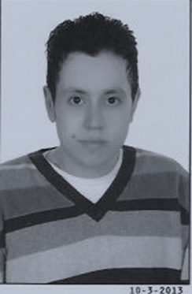
Curriculum Vitae
Personal Profile
Name: Ayman Ibrahim Rashed El-Maghraby
Mobile: 01002843843
Date Of Birth: 1/10/1989
Address: Abed Elslam Elshazly st, - Damanhour – Behera- Egypt
Marital Status: Single
Military status: Final dismissal
Email: ayman.elmaghraby70@yahoo.com & aymanelmaghraby470@yahoo.com
Qualification
Bachelor of Commerce, Tanta University 2010
Experience:
Work : As accountant at "Mazaya for contracting and real estate investment company .
- As Accountant at "Faraglalah for food industries" "Egyptico for Elbehira Agent.
- As accountant at "Ever ready Battery Company"
- As accountant at "Elseedy Company"
- As sales representative in "Domty Company" and "Galaxy company"
Skills
- Good internet user
- Good user for most computer programs
- Work at a team
- Work under pressure
- Willing to learn
Language
Arabic : mother tongue
English : Fair

