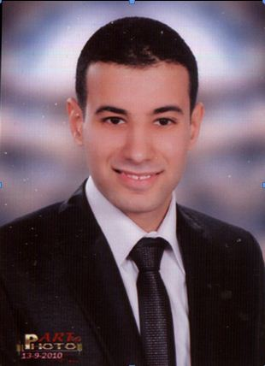

**mahmoud hussein ahmed abdelkhalek**

|  |  |
| --- | --- |
| **10 elnasr st , Tanta, El-Gharbia, Arab republic of Egypt** | |
| **Phone (+20) 40-3346229 Mobile (+20) 1002955748**  **E-mail mahmoud.hussien@live.com** |

|  |  |  |  |  |
| --- | --- | --- | --- | --- |
| **Objective** | | | | |
|  | **S seeking a challenging position in it department ( ERB System) , that enables me to utilize my computer, communication and language skills , fulfills my personal ambitious, enhances my knowledge, and allow me to satisfy my future targets.** | |
| **Education** | | | |
|  | **B.Sc. of commerce, Faculty of commerce, Accounting Department, Tanta University, july 2009.**  **Overall grades: Fair (62%)** | | |
| **Personal Information** | | | |
|  | 1. **Date of birth: 16th April, 1988.** 2. **Nationality: Egyptian.** 3. **Marital status: Married.** | | |
| **Work experience** | | | |
|  | | * **Fresh oracle financial consultant** * **Accountant at the General Company for Land Reclamation Development and Reconstruction (Jun, 2010 – Dec,2010)** * **Accountant at ibrahim khalifa conracting company (Jan, 2011 _ Until now)** | |
| **Awards and special courses** | | | |
|  | * **Oracle R12 Financial In Next Academy Partner Of Oracle**   **( Essentials - GL – AP – AR – Assets – Tax – Cash )**   * **ICDL Course (International Computer Driving License), (Microsoft Word, PowerPoint, Excel, Access, IT, Net and Windows).** * **YAT Professional Diploma In Accounting (YPDA ). (96 hours Education)**   **Course Included ( Windows – Internet - Advanced Excel - Access Core - Peachtree Quantum 2010 - Accounting Auditing - Accounting with Computer - Macro Techniques )**   * **PFAC ( professional Financial Accountant Certified ) From Ain shams Unversity**   **Including :- (Financial Accounting -Cost Accounting- Financial analysis)**   * **English Conversation Intermediate Certificate From Cambridge Training College Britain** | | |
| **Contact information** | | | |
|  | 1. **10 Elnasr st , Tanta, El-Gharbia, Arab republic of Egypt .** 2. **Phone (+20) 40-3346229** 3. **Mobile (+20) 1002955748** 4. **E-mail mahmoud.hussien@live.com** | | |
| **Personal skills** | | | |
|  | * **Self-motivation.** * **Ambitious.** * **Creative & Analytical thinking.** * **Excellent geographic orientation.** * **Team work orientation.** * **Working under stress.** | | |
|  | | | |
|  | |  | |
| **Accreditations and licenses** | | | |
|  | **Driving license: Valid and clear.**  **Military service: Exempted.** | | |
| **Languages** | | | |
|  | **Arabic: Mother Tongue**  **English: good (spoken/written)** | | |
| **computer skiils** | | | |
|  | * **Microsoft office.** * **Very Good experience in Small business accounting and office accounting.** * **Very good user of Peachtree.** * **Very good user of Simply Accounting.** | | |