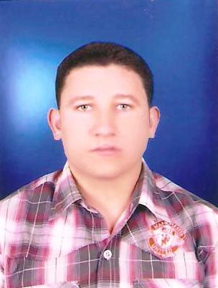
C.V))

Ahmed Mesaed Elsayed Mesaed | Name :
1-1-1989 | Date of Birth :
Kom Abood –Bassion - Elgharbiya | Place of Birth :
Muslim | Religion :
Egyptian | Nationality :
Exempted | Military Status :
040/2702314 | Number Home :
01121423240 | Mobil :
Ahmed Mesaed@yahoo.com | E-mail:
Single | Marital Status :
Bachelor of Commerce – Tanta University | Qualification :
Accounting | Department :
Good | Grade :
2010 | Graduation Date:
American Diploma in Accounting Sciences. | Training :
 Course in Tools To support Companies.
 ICDL.
Course in Customer Service . 
 Course in Computer Maintenance.
Arabic :Volubility Language.  English : Good . | Language Skills:
Training in Accounting Office .  Accountant in( ElshaerTrade of paper Company) .    Cost Control in(Omar Oasis Restaurant).  Accountant in( Delta Foods For Industrial).  Accountant in ( Green Valley For Industrial Foods).  Very Good in Using Microsoft Windows, Microsoft Office ,Very Good in Using Prepared Systems and Computerized Accounting .  Very Good in Prepare journal entries ,general ledger,subsidiary accounts, Prepare trial balances and Financial Statements . | Experiences :
Work Motivated .  Team Work .  Learn Quickly . | Personal Skills:

