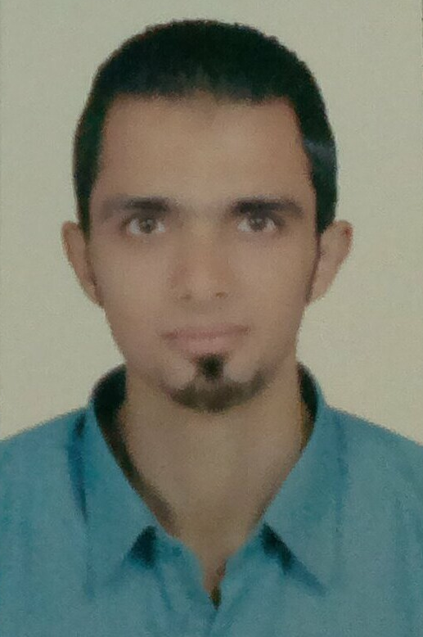 CURRICULUM VITAE
*Personal Data
Name : sherif Mohamed Hussein
Date of Birth : 18/3/1988
Nationality : Egyptian
Marital Status : Single
Military Status : Exempt
Address :68st El Imam Liethy –Al Khalifa
E-Mail :
sherif201277@yahoo.com
Telephone : (02) 25132305
Mobile : (202) (0110) 0281959

*Education
2011:
• Pkarrius Trade
Department of Business Administration
*Second, previous work:
Accountant company Alektruckom Trading & Contracting
From August 2011 to July 2012
* Current work:
Accountant Egyptian German Company for Trading & Supply
(EGTS). From July 2012 - so far
* Nature of the work:

Treasury movement revenues and expenses, customers, suppliers, Covenant, purchases, sales, a. Pay, a. Catch, checks under collection, banks pound and foreign currencies, accrued expenses, the predecessor of staff, operations, expenses paid in advance, wages, administrative expenses and general and financial center

*Capabilities
- Ability to work under pressure with Tight Deadlines.
- Self Motivated, Willing to learn, Team oriented and patient.
- Ability of dealing with different Kinds of people.

*Language Skills
• Arabic : Mother tongue
• English : Good (spoken & written)
Read & Listen | Writing | Speaking
Good | Good | Good

* Computer Skills
Obtained the ICDL certificate

Computer Software:
• Operating System: Dos, Windows2000 & XP & Vista& 7
• Applications: Microsoft Office (Word)…..good

