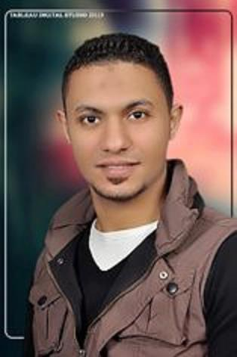

***CURRICULUM VITAE***

**P E R S O N A L D A T A**

* **Name : Mostafa Mosaad Mohammed Hassan**
* **Address :** 3, El -Maghraby St. , Al Agizi, Tanta
* N**ationality** : Egyptian
* **Mobile**  : 01009214458 - 01010950400
* D**ate** o**f** B**irth :** 1st April 1989
* M**arital** S**tatus** : Single
* **Military Status** : Done

**OBJECTIVE**

To join an honorable company such as yours is a great opportunity for me in Order to increase my potential and provide you with service gained through My experience for both of us to be able to achieve success.

**E D U C A T I O N**

Bachelors in Accounting, Faculty of Commerce,

Tanta University, 2010.

**E X P E R I E N C E**

* Accountant in Hogar for construction & development 2012- 2015
* Accountant in El Shrouk for Medical Necessities 2010-2011

**R E S P O N S I B I L I T I E S**

* Achieving of all administration works.
* Ensuring that accruals for all expenses and revenues are properly booked monthly.
* Reconciling balance sheets accounts and preparing analysis on

Revenue and cost.

* Book keeping of the company‘s daily activities:
* Receiving invoices, coding them to the right cost categories,
* Gathering all required documentation that are required by the external Auditor.
* Fully responsible for accounts payable and the related reconciliation.
* Dealing with banks for facilities, bank guarantees and other issues.

**C O U R S E S**

* A course in Financial Accounting
* Training under the supervision of a Certified Public Accountant

**SKILLS**

**Language:**

* Arabic : Mother Tongue .
* English: Good .

**Computer Skills:**

* A good user for Microsoft office .

**Accounting programs:**

* A good user for both the Peachtree and the Quick books.