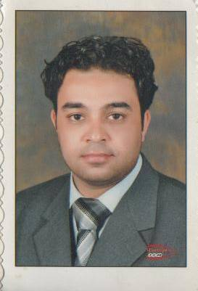
Mohamed Ahmed Ahmed Elsafty

Personal Information | - Marital status : single  - Nationality : Egyptian  - Address : Borg el Arab, Alexandria  - Military status : exempted  - E-mail :mohamudsafty85@hotmail.com  - Driving license: available  - Date of birth :23-2-1985  - Phone : home : 03 4592188  Mobile: 01227612944
objective | - Utilizing and enhancing my skills and qualifications through a big organization which encourage continuous education and development of its employees and through which I can interact and work efficiently in a dynamic environment to prove my self.
Education | - Diploma in Auditing and Accounting, Alex. University,2015  - Bachelor of English commerce, business department Alexandria University, 2007.
Languages | - Arabic – mother tongue.  - English – very good (writing, reading, listening)
computer skills | - Microsoft office and internet  - ICDL certification
Professional skills | - self-motivation and determination to gain more experience in real-world practices and skills  - self-reliant, capable of a team as necessary  - Ability to work under stress  - Able to learn more tasks quickly and target oriented
Experience | - Now I am working in Sinaidivers in Dahab city I am responsible for the accounts of the center which include income , petty cash, and bank operations and also reviewing the invoices which I receive from the counters but I started my career in 1/2/2008 in (EGYPTIAN CO. FOR ARTIFICIAL WOOD) in Tanta , The nature of my work in the company's banking operations such as check cashing and deposit money, bank transfers and all other banking operations, plus I oversaw the spare parts store and sometimes the Company’s Treasury then moved to work in timeshare company as a sales rep.

