**Mohamed Samy Mostafa**

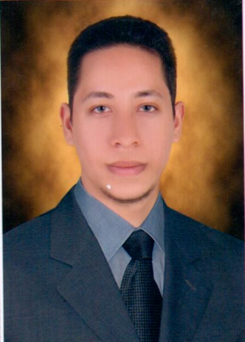

**Age:** 29

3. Kamal Hamza st, Elmarg, Cairo, Egypt 11312

**Cell phone:** 01003495708

**E-Mail:** egyptmido12@yahoo.com

Personal information

**Date of birth:** April 8, 1987

**Place of birth:** Cairo- Egypt

**Nationality:** Egyptian

**Marital status:** single

**Military Service:** Executed

**ID Number:** 0103738

Career objectives

* Obtain a position in an administrative area where I can apply my skills and loyalty in exchange for career guidance, training and opportunity for advancement.

Education

**Ain Shams University**, Faculty of Commerce (Cairo, Egypt) Sep 2004 - Aug 2008

Bachelor of Science

Major: **Accounting**

Grade**: Pass**

Skills Summary

* **Languages**

Arabic (mother tongue)

English (good)

* **Soft skills**

Communication, Presentation and Time & Stress Management (excellent)

* **Computer skills**

Accounting on Excel, Access, Word, PowerPoint and Internet (V.good)

Experiences

June 2010 – July 2011 working at Sayed Esa accounting office (**E.S.A)** on

Accounting works from preparing journal entries

to preparing the balance sheet and the ending

Accounts.

July 2011– December 2013 working at El Masreen Trading company on

Accounting works from preparing journal entries

to preparing the balance sheet and the ending

Accounts.

December 2013– tell Now. working at Company El Roaya Contracting on

Accounting works from preparing journal entries

to preparing the balance sheet and the ending

Accounts.

Professional qualification

* **English courses**

Oct 2007 - Mar 2008 two levels- Ministry of defense (**MODLI**)

* **Soft skills courses**

July 2008 - Aug 2008 Communication, Presentation, Time & Stress Management-

**Ain Shams University**

* **Computer courses**

Mar 2007- May 2007 Windows, Word and Excel- (**L.D.C**)

Professional Memberships

**The merchants syndicate** membership.

References

**Available upon request**.