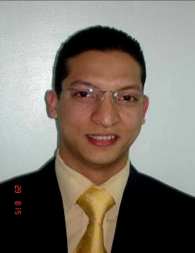
Islam Fayez Mohamed Abdallah

Personal Data:
Nationality: | Egyptian
Date And Place Of Birth: | 1-2-1981
Marital Status: | Married & have 2 children
Military Status: | Exempt
Address: | Block 5 No.18022 Ninth District - Al Obour City
Email: | Smsm_F1981@Hotmail.Com
Telephone No.: | +202-43125503
Mobile No.: | +202-01005512217
Hobbies: | Gym – Computer-Reading

Education:
Faculty Of Commerce: | Bachelor - Accounting Section – May 2002  Ein Shams University
Secondary School | El Tabary School -1995
Languages:
Arabic: |  | Mother tongue
English: |  | Good

Training Courses:
Computer:
 |  |  | Microsoft Word Xp.
 |  |  | Microsoft Excel Xp.
 |  |  | Microsoft Access 2000
 |  |  | Microsoft Access Xp.
 |  |  | Adobe Photoshop7.0.
 |  |  | Internet
Experience :
Company : Water World International
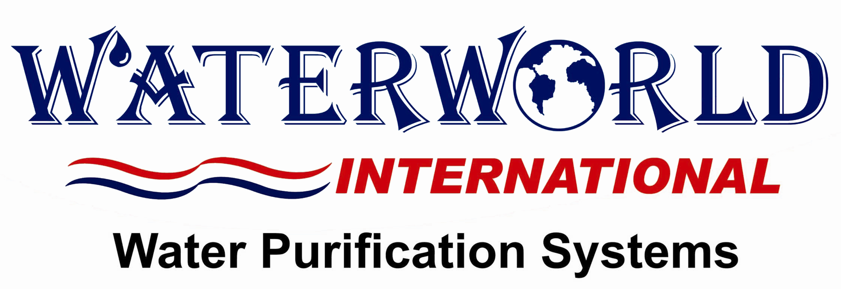
Accountant: | March 2003 – March 2006
Financial and Administrative Manager | March 2006 –till now
Job Description: | - Dealing with and using the financial and administrative system (El Ameen For Financial And Warehouse).  - Dealing with and using Sap System (Database Epicor).  - Dealing with and using the following programs (payable-receivable –general leisure -inventories-purchasing - revenues).  - Dealing with different banks (form 4 banking transaction).  - Audited temporary & standing advances.  - Audited all clients / suppliers invoices & claims.  - Audited responsible for managing the HR. function.  - Audited all bank accounts & preparing adjustments memos. (9 Accounts).  - Prepared daily accounting constraints.  - Prepared monthly trial balance.  - Prepared budget & sheet balance.  - Prepared needed financial reports.  - Prepared annual financial statements.  - Following up internal & external purchases.  - Finishing all customs clearance procedures for all imported goods (Alex office- Ain El Sokna office-Port Said office- Airport).  - Following up all legal affairs ( renewal of the company’s papers)  - Following up all about company’s insurance and its properties and assets (branches, stores, cars….)  - Following up all about propaganda and advertising.
Company Blue Nile For Water Purification
Accountant: |  | October 2002- March 2003
Job Description: |  | - Prepared daily accounting constraints.  - Prepared monthly trial balance.  - Prepared monthly payroll & dues.  - Prepared annual financial statements.  - Finishing all customs clearance procedures for all imported goods (Alex office- Ain El Sokna office-Port Said office- Airport).  - Dealing with accounting programs.  - Dealing with banks (letters of credit)
Mohamed Abdallah Office Accountant & Auditors
Accountant: |  | October 2002- March 2004
Job Description: |  | - Auditor  - Prepared periodical reports.  - Prepared monthly trial balance.  - Prepared annual financial statements.

Training On Accounting And Auditing: | - Gital For Metal Furniture  - Pure For Water Purification
Certificates:
Experience Certificate From: | - Water World International – Water Purification Systems Company.  - Blue Nile For Water Purification.  - Mohamed Abdallah Office Accountant & Auditors.

Skills: | - Dealing and using computer servers connected with - (Lan ) computer networks - printer networks – internet.-warning Devices – security cameras  - Prepare and supervise providing (furniture- equipment - devices …).to the company & its branches.

