

sara tarek mohammed

My CV



19/11/2016

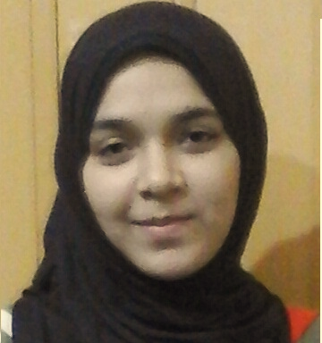

Sara tarek Mohammed.

I'm 20 years old

I'm Egyptian

I live in Al gharbya district, Tanat city0

I'm Muslim

Phone number: +20_01025692373

My passport number: A12410633

**Practical Data**

**\*\*\*\*\*\*\*\*\*\*\*\*\*\***

My **Study:**

I go to arts faculty, Tanta University

I study geography, survey brunch

I graduated from Tanta secondary school in 2014

………

**Skills:**

I'm very good at English

I'm pretty well in computer.

I'm enjoy communicating with other

**Work experience: really that is first time I have a work in this side but:**

I trained in many firms

I am vital member in my collage

I done more activities

I love to be worker in yours.

I respect my leaders.

I can learn quickly

I can work under pressure

I'm punctual

I'm good team player

**Additions**:

I take more course for ex: in

English

Icdl

Human developing