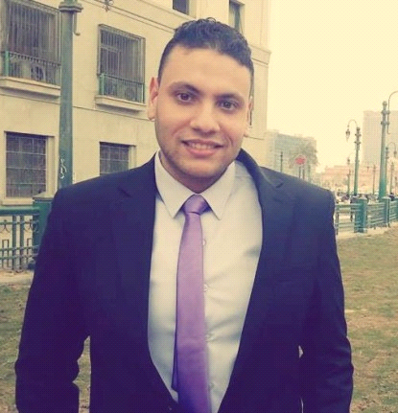

***Moustafa ELsbaiy ELdeeB***

***Accountant***

**Phone: +2-01022918449**

**Email :**  **M.elsbaiey@gmail.com**

**Address : El Gharbeia - Zefta – ELBHR ST**

**Address2 :** **Cairo – Nasr city - mkram EbeedS.T**

**Career objective**

Seeking a challenging career in a professional and respectable international organization where my skills can be efficiently utilized and further developed ..

**Personal Information**

**Date Of Birth :** september 6 ,1990 **, Nationality :** Egyptian

**Marital Status :** Single **, Military Status :** Was performed

**Religion :** Muslim

**Academic qualifications :**

***Bachelor of Faculty of Commerce Tanta University , ENGLISH SECTION***

***Accountant Dept : 2012.***

***Graduation degree passed.***

**Courses & Computer skills :**

* **English language course**.

(General and conversation courses in American university)

* **ICDL** (Windows-Word- Excel- Power point- Access-Internet-Outlook-IT-Wmail)
* **Holds training course in Excel accounting**

**Language**

**Arabic :** Mother Tongue

**English :** Very Good of both in spoken and written

**French :** Fair

**Experiences & Training**

**-Training in an Accounting Office during the study .**

**-Working in mobinil store customer service**

**-working as accountant and translator in rose taxtile company in 10th of ramdan**

**- accountant in aswan company for Construction**

**Hobbies**

Football, Play chess, swimming, Trips, Friendships, Reading the news of political and economic.

***Thank you for giving me an opportunity to join yourTeamwork.***