Mahmoud Abul Hassan Mohammed
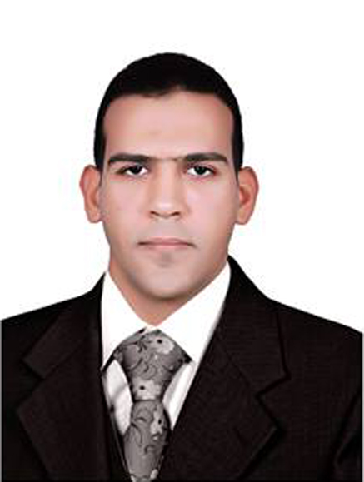

Address: Tah_Shubra , Quweisna , Monufia , Egypt.
Mobil-: (002)01203292151 /Home -:(002)0482499065
E-mail-: eng_mahmoudabulhassan@yahoo.com
G-mail-: engmah990@gmail.com

JOB OBJECTIVE

I'm a civil engineer( Implementation, design and technical office )
EDUCATION | - Bachelor of civil Engineering  Year of Graduation : 2012  Faculty of Engineering, Monufia University  Graduation Project : Structural Analysis Of Buildings  Graduation Degree: Good (71.8%)  Graduation Project Degree : Excellent
COMPUTER SKILLS | Good Command Of:  - Auto Cad  - Sap 2000  - Microsoft Office ( Word, Power Point, Excel )  - Internet Technology  - Operating System ( Win XP , 7 , 8 , other )
LANGUAGES | Arabic : Native language  English : Very Good ( Read , Write , Speak and Listen )
TRAINING | - TRAINING IN :-  Arab contractors Company to setting up National liver institute  at Shebin El Koum (the new building )  Project info: A 5000 m2 mostly concrete building with 9 floors  Duration: 1 month ( from 4/7/2010 to 2/8/2010 )  - My Graduation Project :-  Structural Analysis Of Buildings. It contains designing of villa  and 2 a residential tower 11floors.
EXPERIENCES | 1-I worked for Ayman Badr Contracting office as engineer  implementation of the finishing works for residential building  “Owner the Ministry of Housing" .  2-I worked for a Elmadaen company of foundations and constructions  (site engineer) . I've supervised the work of 5 Buildings .  “Owner Badr City Authority”.  3-I'm worked for wael serag Contracting office as site engineer ,  Implementation of a residential building from drilling toFinishing  "Owner the Ministry of Housing".  4- I'm worked for the Office of Gamal Zoghbi Contractingoffice as  implementation engineer to set upa pool fence School of Seven  advanced 450 m (striping and separate rules)  "Owner Educational Buildings Authority"  5- I'm worked for Horse Alex the company for engineering works as  engineer implementation of the project sewage Integrated Center  (Expulsion lines and networks and the expulsion of lift stations)  "Owner water company and sewage lake"
PERSONAL DATA | Date of Birth : 2nd April 1990  Gender : Male  Nationality : Egyptian  Religion : Muslim  Marital Status : single  Military Status : Completed
SOFT SKILLS | - Interactive and fast enough to learn new technologies  and sciences.  - Advanced Research Abilities.  - Highly Communications skills.  - Self-Motivated.  - Ambitious.  - Team leadership abilities.
HOBBIES & INTERESTS

Reading and football .

Thank you for your Time

