Mohamed Salama Mohamed Gafaar
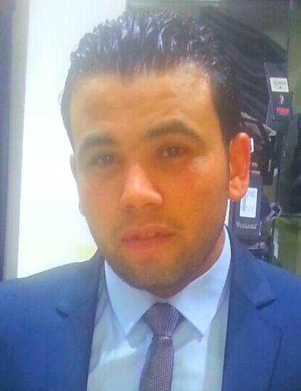
- Contact : Address : Tanta,Gharbia , Egypt

Mobile : 01226670836_01098294477

E-mail : Mohamed_salama_acc @yahoo.com
    - Objective :
Seeking apposition as an accountant where extensive experience will be further developed and utilized, this provides an opportunity for both greater responsibilities and future advancement.
    - Education :
- Graduated from Faculty of Commerce Tanta University , 2009-2013
- Major : Accounting.
- Final Grade : very good .

Courses :
- Training For Employment : Principles of Banking Certificate
At ( Egyptian Banking Institute ) 19 Feb 2014 - 10 Mar 2014

Covered Topics:
· Credit and financial analysis.
· Retail banking operations.
· Foreign trade finance operations.
· Business awareness: Written Communication, Etiquette at workplace and presentation skills.
· Bank Accounts and deposits.
· Introduction to Customer service.
- English Course "Conversation"
at "AXON" Academy Jan 2013 - Oct 2013
- ICDL syllabus Version 5.0 28 Nov 2013
Skills :
- Language
- Arabic : Mother Language.
- English : Very good in spoken, written and reading.
- Experience :
- working accountant in Dr. Abd ElRasoul Abdel Hadi Tanta Branch Office to gain experience.
- Now I work in Jovi tronix company for trading agence HTC-Lenovo and I work on programs (Smart _Ax )

Computer knowledge :
- Very good on basic skills in Microsoft Office applications.

- Excellent user of windows, Internet.

Personal
- Excellent communication skills .
- Ability to prepare (balance sheet – owner’s equity – income statement – cash flows).
- Handle customer inquiries and requests , achieve customer satisfaction.
- Willingness to learn .
- Develop my self all the time .
- Ability to learn Quickly ,enthusiastic,active.
- Well organized ,work under pressure .

Personal Information :
- Date of Birth : oct 24,1991.

Military Service : Exempted .

Marital Status : Single .

Nationality : Egyptian.

. Certificates and Recommendations Letters are furnished upon request.

