Curriculum Vitae

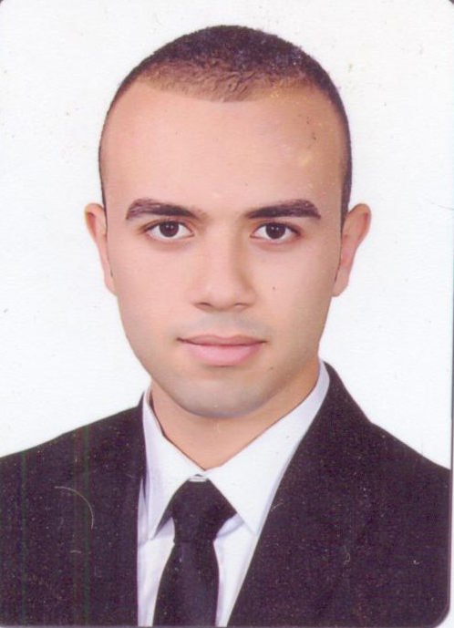

Abd El Fatah Magdy Ebrahim El Domiaty
Mobile : 01062077031 – 01151015044.
Home phone: 0402552426
Email : Magdy_eb30@yahoo.com
Job Objective
Seeking a challenging position leading to successful career in reputable organization in which I can develop and apply my skills.
Personal Information
Nationality  Current Job | :  : | Egyptian  Examination Invigilator. ( British Council ).
Date of Birth | : | 4/12/1992
Marital Status | : | MARRIED
Gender | : | Male
Military Service | : | Exempted
Family Address | : | 27 Ibn Sina st - Kafr El Zayat- Gharbya.  4B PRIMROSE LANE , JACKSON, NEW JERSEY , UNITED STATES OF AMERICA
Education
- Bachelor of Commerce – Accounting Department.
- Year of Graduation: May 2014 with grade Good.
- University: Tanta.
Computer Skills
- ICDL.
Word, PowerPoint, Excel, Access, Net, Information technology.
Languages
Arabic : Mother Language .
English: Excellent in Writing and reading, Fluent in talking.

Experiences:
- Examinations invigilator at British Council Alexandria.
(April 2015 – June 2015) (October 2015 – June 2016).
Invigilate The International General Certificate of Secondary Education from Cambridge. (IGCSE Examinations)
- Fitness Instructor for kids, teenager and people who suffer from overweight. (Second Job).
Train the people who suffer from overweight in groups to encourage and support each other.
- Accountant at Alseba Company for herbs and spices at 6October Industrial City. (July 2015 – October 2015).
Responsible for All Financial Transactions with Banks, clients and suppliers.
- Accountant and Customer Service at Mecca farms for poultry productions. (September 2007 – May 2013).
Responsible for all financial and non-financial transactions, And dealing with suppliers and customers and work to solve their problems.

