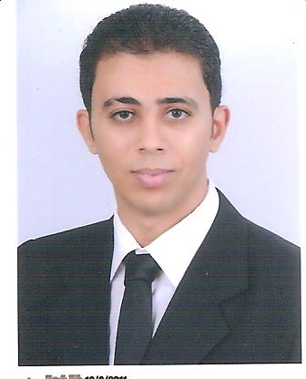
c.v
Ahmed mahmoud elsayed
Shebin al-kom - Elmenofia- Egypt
Tel: (+2) 01001121576
Email: ahmedelmahroka@yahoo.com

General Information
Age: 26
Military services: Finished
Mother Language: Arabic
Second Language: English

Education:
- 2008-2011 Bachelor of Commerce Department of Business Administration Good estimate 75%

Work Experiences:
- Sales in fathy hassan group
- Sales retail in mini franchise etisalat
- Team member marketing in uni-group

Computer Skills:
- ICDL
Other Skills:
- excellent selling
- Negotiation
- Time management
- Management meetings
- Decision-making
- Design of survey
Adjective:
- Ambition
- Very responsible
- Hardworking
- Good presentable
- Excellent communication
Courses:
- 2016 communication skills (online course)
- 2016 project management (online course)
- 2016 Marketing through social media (online course)
- 2009 Leadership Development in Institute of preparing leaders in Helwan
- 2010 Training sessions ICDL
Study Experiences:
- Sales
- Marketing research
- Survey design
- Strategic Planning
- Feasibility studies

