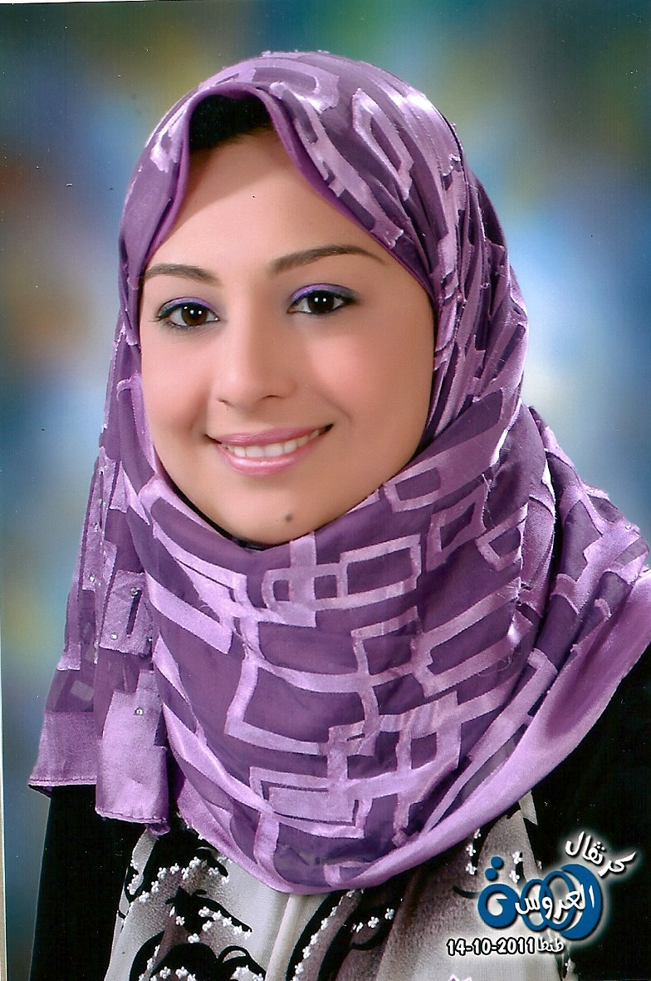
Name:- Mona Mohamed Ali Rady

Personal Information | - Date of birth: 19th of November, 1987.  - Address: (9) El_Ashry St From El_Glaa St , Tanta, Egypt.  - PHONE: +2-040-3556005  - MOBILE: +2-01005395023 -- 01223759037  - Email :- eng_nona_555@yahoo.com
Objective | - Seeking a challenging career in a multinational company that enables me to develop my skills, acquire practical experience and make beneficial use of my previously acquired knowledge and working experience.
Education | - Bachelor degree of Structural Engineering with grade Accept Tanta University, Faculty of Engineering, May 2009
Graduation Project | - Repair Project with grade Excellent.
Summer Training | - July August, 2007 Arab Constructor.  - El_Eskan And El_Mrafeq In Kafer EL_Shikh.  - July August, 2008: Doctor-Mostafa El_Sawaf Company
Working Experience | - Worked at EL-Riyadh for building & construction company from October 2009 to February 2010  - Worked at Hossam&El_Said Mahmoud Company from March 2010 to November 2011 (Eskan Moubark project in Tanta).  - Worked at EL-Ekhwa for constructing & trading from December 2011 to December 2014.  - Worked at ARCON for constructing from January 2015 to June 2015  - Now working at Hossam&El_Said Mahmoud Company
Additional Courses | - Primavera 6  - AutoCAD Engineering Corporation.  - ( Reference Available Upon Request.)
Communication Skills | - Team building strategies.  - Communication Skills.  - Problem Solving Technique.
Computer Skills | - Excellent internet approach and Windows XP.  - Office tools: Microsoft Word, Power point, Excel, Access.

