**Mohamed Ahmed Hussien**

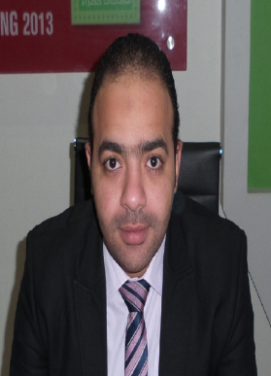

**Address**: alsyoof . Alexandria, Egypt.

**Phone**: +2-01065566698

**E-mail:** **Mohamed.aqarat@gmail.com**.

**Career Objectives:**

Seeking a challenging positioning in the field of sales & marketing in a multinational organization, where I can improve and develop both my personal education and back ground.

**Personal Information:**

**Date of Birth:** August 12, 1987

**Nationality:** Egyptian

**Place of Birth:** kafr elzayat, elgharbia

**Marital Status**: married

**Military Status:** Finished

**Education:**

**Qualification:** Bachelor of Commerce Division of Accounting in English

**University:** Tanta

**Grade:** Pass

**Graduation Year:** 2010

**Experience (8 years)**

* **From October 2008 till march 2016**, I work within the Department of Marketing and Sales at **City Light for constructions and buildings** to manage both general manager of research and marketing studies and director of the branches of Tanta , marketing and sales specialist at the headoffice in alexandria

**Courses:**

* **Preparation toefl course by AMIDEAST.**
* **American diploma in commerce sciences (ADCS) which include : * English accounting * human resource * English conversation * computerized accounting *analyzation system accounting .**
* **Icdl.**

**Language Skills:**

* **Arabic:** Native language
* **English:** Excellent command of (written and spoken)

**Computer Skills:**

* Excellent experience with Microsoft Operating Systems

(XP – Vista-Seven).

* Excellent experience in Microsoft Word & office suits Access ,

Power Point , internet explorer, Outlook and Ms project.

* Well versed of many operating systems.
* Software engineering.
* E-marketing specialist

**Personal Skills:**

* Ability to learn new tasks easily and quickly.
* Ability to work individually or with the team.
* Ability to work well with all levels of management and staff.
* Ability to manage time.
* Ability to work under pressure.
* Problem-solving skills.
* Excellent personal, communication and presentation skills to apply.
* Willingness to aging professional knowledge and experience.
* Willing to relocate.
* Self – motivated.

**Personal Characters:**

* Excellent in Communication, Presentation and Selling Skills.
* Very Good Team Member and Leader.
* Ambitious, Independent, Enthusiastic & Self Motivated

**Documents and certificates are furnished upon request.**

***Mohamed hussien`***