Ahmed El-Saeed Serwah
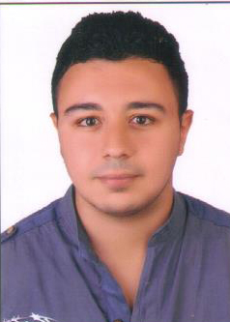
Eng.Serro@gmail.com
002-01002420068

Objectives

- Seeking for a challenging position as a Civil Engineer, where I can use my overseeing skills in construction and help grow the company to achieve its goal.

Education

- Higher Institute of Engineering and Technology KFS
- Graduation Year: B.Sc. Degree in Civil engineering - 2014
- Project Graduation: Management – Project Grade: Excellent

Summer Training

- 1st year summer training at El-Mokawloon El-Arab construction and contracting company
- 2nd year summer training at (Egyptian Contracting (Mokhtar Ibrahim) Company S.A.E.)
- 3rd year summer training at Alsfwa (Dr. Mohamed Rashad) office for construction

Languages

- Arabic : Mother Tongue
- English : Very Good

Programs

- Primavera
- AutoCad
- MS-Office
Personal Information

- Nationality : Egyption
- Date of Birth : July 6, 1991
- Place of Birth : Egypt
- Military Status : Done

Current job

- Works at Alsfwa (Dr. Mohamed Rashad) office for construction

REFRENCES Available upon request

