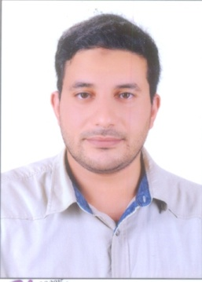 Ahmed Refat Alnagar.

37 Orabi Street, kafer elzayat ,El Garbia, Egypt.

Cell: 01000272854 – 01111271681.

Email:ahmedrefat85.ar8@gmail.com

**Personal information:**

Date of birth: 26 May 1985.

Citizenship: Egyptian.

Gender: Male.

Marital Status: Single.

***Objectives:***

**To find a challenging position to improve my competencies, capabilities, skills and experience.**

***Employment History:***

**ISA Academy** May, 2006 –Dec,2006.

**Work as a trainer for ICDL courses.**

**Connect company for cell phones and computers.** Dec,2006 – Dec,2007

**Holding a position as an Accountant with the following responsibilities: preparing daily accounting journal entries, following up safe and storehouse, dealing with suppliers, customers.**

**First Company for constructions**. Dec. 2007 - Dec.2010

* **Holding a position as an Accountant with the following responsibilities: preparing daily accounting journal entries, following up safe and storehouse, dealing with suppliers, contractors and clients and preparing balance sheet.**
* **Auditing and** Work as a **replacement** for Chief Accountant.

**Alsalam Specialized Hospital March . 2011 – Current**

* **Holding a position as an Accountant with the following responsibilities: preparing daily accounting journal entries, following up safe and storehouse, dealing with suppliers, contractors and clients and preparing balance sheet.**
* **Auditing and Work as a replacement for Chief Accountant**.

***Education*:**

Faculty of Commerce.

Department of Accounting.

Degree: Bachelor.

Grade: Fair May 2007.

***Professional Qualifications:***

**1. Languages:**

- Arabic - Excellent.

- English - Very good.

- Italian – Level one.

**2. Computer Skills:**

****ICDL Certificate.****

Microsoft Office and Windows.

*3. Driving License:* Valid*.*

**\*References available upon request.**