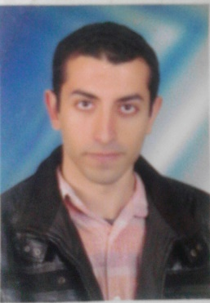 **Elhusssein Mohammed Ahmed Sheple**

**Personal Information :**

**Date of Birth** **:** **13/8/1992.**

**Address**   **:** **Egypt – Elgharbia - Qutour.**

**Contact Tel.** **: 01010854864.**

**Nationality** **:** **Egyptian.**

**Marital Status : Single.**

**E-mail : Engineerroller@gmail.com.**

**Position of recruitment : Has been finished.**

**Education :**

**\* University :** **Kafr El-Shikh University.**

**\* Faculty : Engineering.**

**\* Year of Graduation : 2014.**

**Language skills :**

**Arabic : Mother language.**

**English** **:** **Excellent Command of English , Reading . writing (85%).**

**Personal Skills :**

**\* Good communication skills & have wide relations.**

**\* Ability to work individually or as an active team member.**

**\* Work Under Pressure & Supporting Teamwork.**

**Courses :**

**\* AutoCAD.**

**\* Sap.**

**\* Engineering Supervision and The Assets of Implementation.**

**Experience :**

* + - * **Arab contractors at Alex branch training as student on structure sites.**
      * **Arab contractors at Kafr Elshiekh branch training .**
      * **Some individual companies after graduated for training and to get experience.**