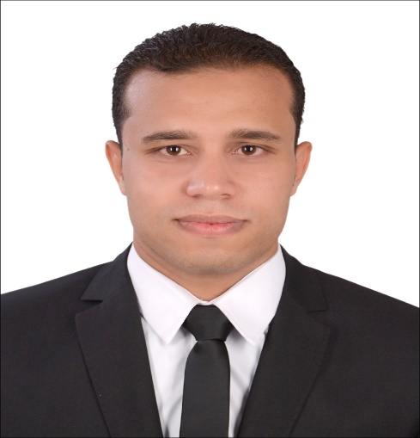

**Mostafa Hamed ElsaiedFarahat Nada**

Egypt – Al minufyah –shibin Alkawm

01009375630

[*Mostafa.hamed381@yahoo.com*](mailto:Mostafa.hamed381@yahoo.com)

*15th Jan 1993*

*Personal Profile*

I am a Person who insists to achieve his dreams to be in the best place , benefit his country and make a great future for himself .

*Education :*

2011 finish secondary school in shibin Alkawm

total Degree 96.4 %

2016 finish Bachelor in civil engineering minufyah university

GPA: ***very good*** *“ 79.43”*

Graduation Project title :***“Reinforced Concrete Structure” ,***

***“excellent”***

***Work Experience***

2014  **PETROJET**

Trainee Engineer

2015 **Doha for Engineering Consultancy**

Trainee Engineer

***Skills:***

***-languages***

***\**** *Arabic “mother language”*

*\*English “good”*

*-****computer skills:***

***\*****Autocad 2014*

*\*CSI Sap 2000*

*\*CSI Etaps*

*\*CSI Safe*

*\*CSI Columns*

***-Personal skills:***

*\*time management*

*\*problem solving*

*\*leadership*

***References:***

*- Ready upon your requests*