 |  |  |  | 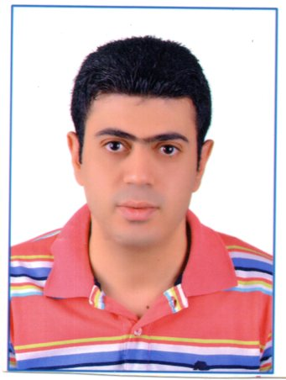
البيانات الشخصية |  |  |  | Personal Information
الاسم الرباعي | محمد عطيه كامل الجندي |  |  | Mohamed Atia Kamel ELgendy |  |  |  | Name
الجنسية | مصري |  |  | Egyptian |  |  |  | Nationality
تاريخ الميلاد | 9/1/1982 |  |  | 9/1/1982 |  |  |  | Birth date
مكان الميلاد | تلا |  |  | Tala |  |  |  | Birth place
الحالة الاجتماعية | متزوج |  |  | Married |  |  |  | Marital Status
بطاقة الأحوال | 1705011 |  |  | 1705011 |  |  |  | I. D. No.
المؤهلات العلمية | التخصص | السنة | النسبة Grade |  |  | Year | Major | Education
بكالوريوس تجاره | محاسبه | 2002 | مقبولPass |  |  | 2002 | Accounting | Bachelor of commerce
 |  |  |  | Experience
From 8/2002:8/2009 Accountant in Elsaada Trade
From 8/2009:7:2011 Accountant in Sana Elyamama Trade
From 8/2011:12/2012 Accountant in Elsaada Trade
From 1/2013:7:2014 Marketing Representative in Misr life insurance
From 10/2015:9/20116 Accountant in Elsaada Trade

Skills
Java2 solution developer From Ministry of communications.
Book Keeping& Introduction to Taxation From HPA.
Computerized Accounting From HPA.
The Basic of Investing in Securities From ECMA.

 | Hlamohamed972014@yahoo.com |  |  |  |  |  |  |  | E-mail
 | 01097663955 |  |  |  |  |  |  |  | Special Tel.
العنوان | تلا- المنوفيه-شارع المعهد الديني |  |  |  | Tala-Elmonofia-Elmahad Eldiny st, |  |  |  | Address

