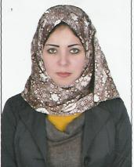

Personal Data

Name :Sara Mohamed El Hofy
Date of Birth : 1/6/1988
Nationality : Egyptian
Gender : Female
Marital status : Single
Computer skills : Very Good

Mobile :01010004181 - 0453696964
Address : Kom Hamada – Elbehera

Education
Qualification : Bachelor of Arts
University : Tanta university.
Graduation year : 2009
Grade : Good
Diploma in Educational (2014)
Damnhur- UNIVERSITY

Language : Arabic (mother language)
English ( EXCELLANT)

Skills&hobbies

1- EXCELLANT in speaking and writing English.
2- Good knowledge about computers and internet
3- accountant , good using accountant excel .

Experience
* Work at Misr unguarded tourism
* Egyptian company working Gulf lmp & Exp

I would like to join your successful team

