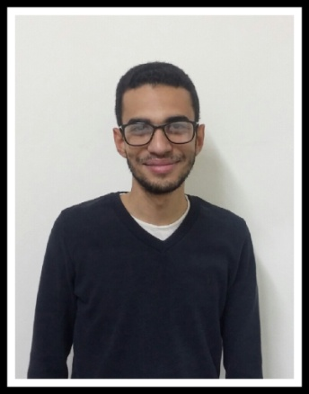

**Mohamed Tarek Mohamed Abo Ali**

**Citizenship :EGYPT ▪ Date of birth :31 of March 1992**

|  |
| --- |
| **Personal information:** |
| **Mobile: 01277667280**  **e-mail : m.tareklivefree@gmail.com**  **Gender: Male.**  **Passeport: Valid** |

|  |
| --- |
| **Education** |
| * **University: Future Academy.** * **Faculty: Faculty of tourism and hotels.** * **GPA: Fair.** * **Graduation Year: 2013.** * **Certificate: Thanawya Amma.** * **School: Ahmadeya School.** |

|  |
| --- |
| **Work Experience:** |
| 1. **Director of Sales in" International Company " for Project Management.** 2. **Trainer in" International Company " for Project Management.** 3. **Sales in "Ace life" for insurace.** 4. **Sales in "Ma’amaar al morshedi".** 5. **Trainer in "Live Free" Company.** 6. **Director of Sales in " sheraa Travel " for Tourism Investment.** 7. **Director of Sales in El-Delta for insurace.** 8. **Director of Sales in " Future Horizons Group "** |

|  |
| --- |
| **Skills and Ability:** |
| * **Personality:** * **Creativity, patience, and self-motivation** * **Increased confidence, initiative, and independence.** * **Punctual, hardworking, and manage stress.** * **Computer:** * **Excellent user of Microsoft's Word, PowerPoint and Excel.** * **Excellently skilled in internet applications.** * **Languages:** * **Arabic: Native tongue.** * **English: Good spoken, written, and read.** |

|  |
| --- |
| **Acquired Courses:** |
| * **Human Resources and Business Administration.** * **Accounting Diploma.** |