Curriculum Vita
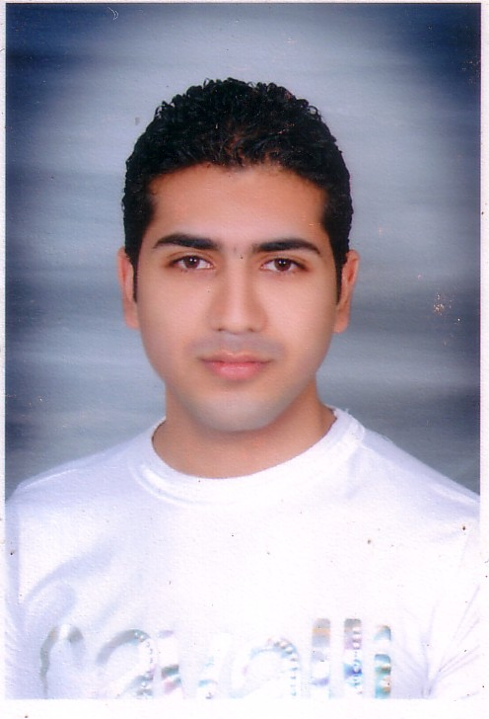

Personal Data:-

ame : Mina Mikhael Awad Mikhael
Address 5 st dar el slam sedey besher alexandria
Military Status : Exempted
N
Tel : 01221529402.
Age : 31 years
Mail :minamikheal402@hotmail.com

Qualifications:

Bachelor of Tourism & Hotels, hotel administration department
Graduation year: 2007
overall grade: very good

Language Proficiency:

Arabic : Mother Tongue.
English : Second Language (very good)
Speaking – writing – listen- and iam speak English well

Skill

- studied some courses in English and have Certificate from American Egyptian Academy

Experience "

mina contracting and development markting department from 9/2015 till date

El masrya el handsya contracting and development markting department from 1/5/2014 to 1/8/2015

_ Mbany company for contracting and development from 20-11-2013 to 30/5/2014

_royal building company for contracting and development ,marketing department from 1/6/2013 to 15/11/2013

_ turkey real estate company, marketing department from 12/10/2012 to 1/6/2013

_ Amer Group company for contracting and development , marketing department from 5-5-2012 till 10-10-2012

_ kiroseiz company for contracting and development , marketing department for 4 year (2008 to 2012)

_ front office at Hilton Alexandria green plaza for one year

_ front office at Hilton Shlalat Sharem El Sheakh 6 month

Computer

_ "Entry Data" – Access--Excel – Word – and Power Point
_ internet
_Fast Typing

Carrying
driver license

Personal Traits:

- Working under stress pressure.
- Working professionally, individually, and collaboratively.
- Patient, and intelligent.
- Loving work and activities that require mental thinking.
- I'm clam and faithful
- Can work with a team work

References:

Will be submitted upon request

