Curriculum vitae

Ahmed Fahmy Yassin Mahmoud

4 Ahmed Amin street, second Floor, Flat no. 6
Al Raml - Alexandria
Telephone:03 - 5761911 (Home phone); 002 - 01271799376 (Mobile)
Email: ahmedfahmyyassin@hotmail.com

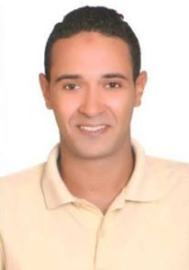

Marital status : Engaged
Nationality : Egyptian
Age : 25 years old ((5-6-1990))
Place of birth : Alexandria
ID number : 29006050200971
Military status : Exempted

Personal Information:

Seeking a challenging position. Possesses excellent interpersonal, communication and negotiation skills and the ability to develop and maintain mutually beneficial internal and external relationships.
Enjoys being part of, as well as managing, motivating and training, a successful and productive team, and thrives in highly pressurised and challenging working environments.

Education and Qualifications:

- B.sc. from Higher Institute for Computer 2011.
- High School : Alexandria Shipyard school 2007.

Personal Details:

- Interests Reading – swimming - fishing.
Current Job:
Sales Officer at Dreamers Tourism Agency, From 2014 till now.

Experience:
Sales Representative at Trust for Tourist Real Estate Marketing, from 2012 till 2013.

Extracurricular Qualifications:

- Possesses a maritime Passport.
- Has completed training courses in rescuing,fire fighting and first aids From Arab academy for science technology and maritime transport.
- Enrolled in the syndicate of commerce.
- eal Estate Obtained a certificate of merit from Trust for R.

Language and soft skills:
- Arabic : Mother Language.
- English : intermediate.

Soft skills:
- Negotiation skills.
- Ability to resolve conflicts and work under pressure.
- Customer service and Dependability.
- Hard worker, truly ready, team worker, charisma and leadership.
- Creative Problem Solving.

Note: Further credentials will be furnished upon request...

