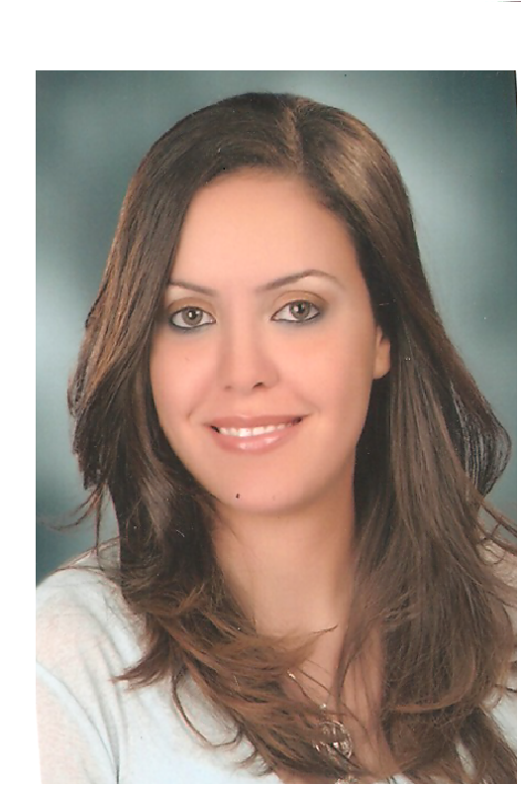

Personal Information

Full Name | Ghada Mahmoud Ahmed Omran
Date of birth | 12/12/1984.
Material status | single
Address | 3 karam street shods ,  alexandria . egypt
Mobile  Home | +2 01223929939  +2 035774058
E-mail | Ghada_omran1212@yahoo.com

Career Objectives

Seeking a challenging career opportunity that would give me the chance to be an effective member of an executive team in a successful International Organization, where my knowledge and skills can be shared and enhanced.

Education

- School : high school certificate

-University : Bachelor of Social work 2001–2005.
Alexandria University.

- Grade: Good.


Languages skills

Arabic: | Mother-tongue. Excellent speaking, Excellent writing
English: | Excellent command
Computer skills

Computer courses acquired:

- Base concepts in Operative Systems. Computer Use and files management (Microsoft Windows 98, Millennium, XP).
- Office Package: efficient user of Word, Excel, PowerPoint, Access and Internet main definitions. Internet use for data and documents research (search engines).
- E-mail management, in particular Outlook and website.
- Using all office application (facsimile machine, photo copier, scanner, and printer ….etc.)

Courses

The courses are specialized in the following fields and provide:
▪ Ability to use communication and information management tools in different fields of jobs.
▪ Capacity trading protocol receptions and public relations field

- 2007: ICDL course.
- 2012: marketing management course at – Arab Academy For Science and Technology & Maritime Transport ( Conducting )
- 2014: complaint handling
- 2015: customer service basic




Future plan

- To have my own business

Personal skills

- Strong communication and interpersonal skills.
- Highly motivated with substantial teamwork ability and communication with team members.
- Ability to work under pressure and to tight deadlines.
- Honesty and reliability.
- Attention to detail.
- Flexibility and adaptability to juggle a range of different tasks and to work extra hours to meet deadlines.
- good organisational and time management skills
- Dynamic, creative, hard worker
- Fast learner and reliable
- Ability to work under pressure
- Ability to meet deadlines
- Team player
- Good problem solving skills to identify and resolve problems
- Professional organizing and planning skills

Personal interests

- Travelling and get in touch with new cultures
- Drawing and Reading.
- Practice sports such as, swimming
Past experience

Company : New horizon training center

Position : customer service representative in

From : 2007 till 2008


Company : Mena for constructions & trading

Position : Marketing Specialest

From : 2014 Till Present

Type of work : - Preparation for real estate exhibitions.
- Responsible for design and execution of all advertising
materials of the companys projects.
- Including dealing with advertising agencies.
- Printing houses and press organizations.

Position : Personal Assistent CEO

From : 2015 Till Present

Type of work : Fulfillment of technical secretarial, administrative and logistics of Chairman & CEO and library management efficiency and effectiveness, and follow up all contacts and arrange appointments and necessary meetings
