 | Ahmed ShabanAbd El Aziz
 | Ahmed Shabaan Abdel Aziz
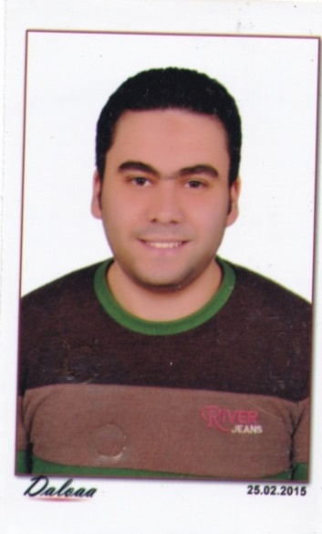 | 6 Gmeay St. Fleming. Alexandria – Egypt.  01116598646  Ahmed0shaban.as@gmail.com  Personal Information  Date of Birth:15th of June1989  Military Status:Exempted

Objectives:
To deliver friendly and effective service, that creates a warm and welcoming atmosphere for all our guests. The key aim of this position is to retain and attract new customers and also provide high levels of internal Service.
Education:

*License degree of Faculty of Law – Alexandria University.
*Date of Completion: June 2011.
*Cumulative Grade: Good.

experience:
*Gernal Manager at Turky For RealEstate and Legal affairs official.
- From June 2013 tillCurrently
*Guest Relation Manager at SanStefno Grand Plaza
From October 2013till 2014

*
*El Fatem Group at Carrefour Legal department.
- September 2011 to May 2013.
*El Fatem group at Carrefour as Operator
- From August 2008 to September 2010.

skills:

*Computer: Advanced knowledge of MS Word, Excel and Outlook.
*Languages: Arabic (native), English (Good)
*Friendly, Confident, Polite, Organized
Interests:
*Reading , Painting, Music and Sports
My Goal :
*To gain an opportunity to work at your company
Or facility in décor field where my experience ,
Formal education , technical skill – set and
Strong work ethic can achieve success for both,
The firm I represent and myself.

